Study of Tungsten Shielding Before CTOF to Limit its PMT Currents

V. Burkert, D.S. Carman, L.C. Smith, M. Ungaro

*Jefferson Lab, 12000 Jefferson Avenue, 23606 Newport News, VA, USA*

**Abstract**

Simulations of beam-related background were performed for four thicknesses of tungsten shielding cylinders between the CLAS12 Barrel Micromegas Tracker and the Central Time-Of-Flight (CTOF) system. The detector rates and PMT anode currents were determined. The geometry includes the latest engineering models of the target and the CLAS12 solenoid magnetic field at full strength.

**Simulated Detector, Shields, Beam, and Target Configuration**

This simulation study used the GEant-4 Monte-Carlo (GEMC) package and is based on the CLAS12 standard configuration for Run Group A. The target and its vacuum elements were incorporated into GEMC directly from the engineering CAD models [1]. For each event 124,000 electrons were simulated going through the target within a 248.5 ns time window. This corresponds to the full CLAS12 nominal luminosity of 1035 cm-2s-1 on a 5 cm liquid-hydrogen target. Simulations were performed for a 10.6 GeV beam energy.

The nominal three layers of the Barrel Silicon Tracker (BST) and Barrel Micromegas Tracker (BMT) were present in two geometry variations: one with a 51-m-thick tungsten shield cylinder surrounding the foam scattering chamber and one without it. This shield layer was installed in CLAS12 on Feb. 5, 2018.

Five additional shielding configurations were studied, corresponding to 0.1, 0.5, 1, 2, and 3 mm thick tungsten shielding between the BMT and the CTOF. The length of these shields was chosen to cover the full scintillator length as shown in Figure 1.

Counter rates and vertex positions for events that left energy in the CTOF were extracted for several particle types and the PMT anode currents were calculated.

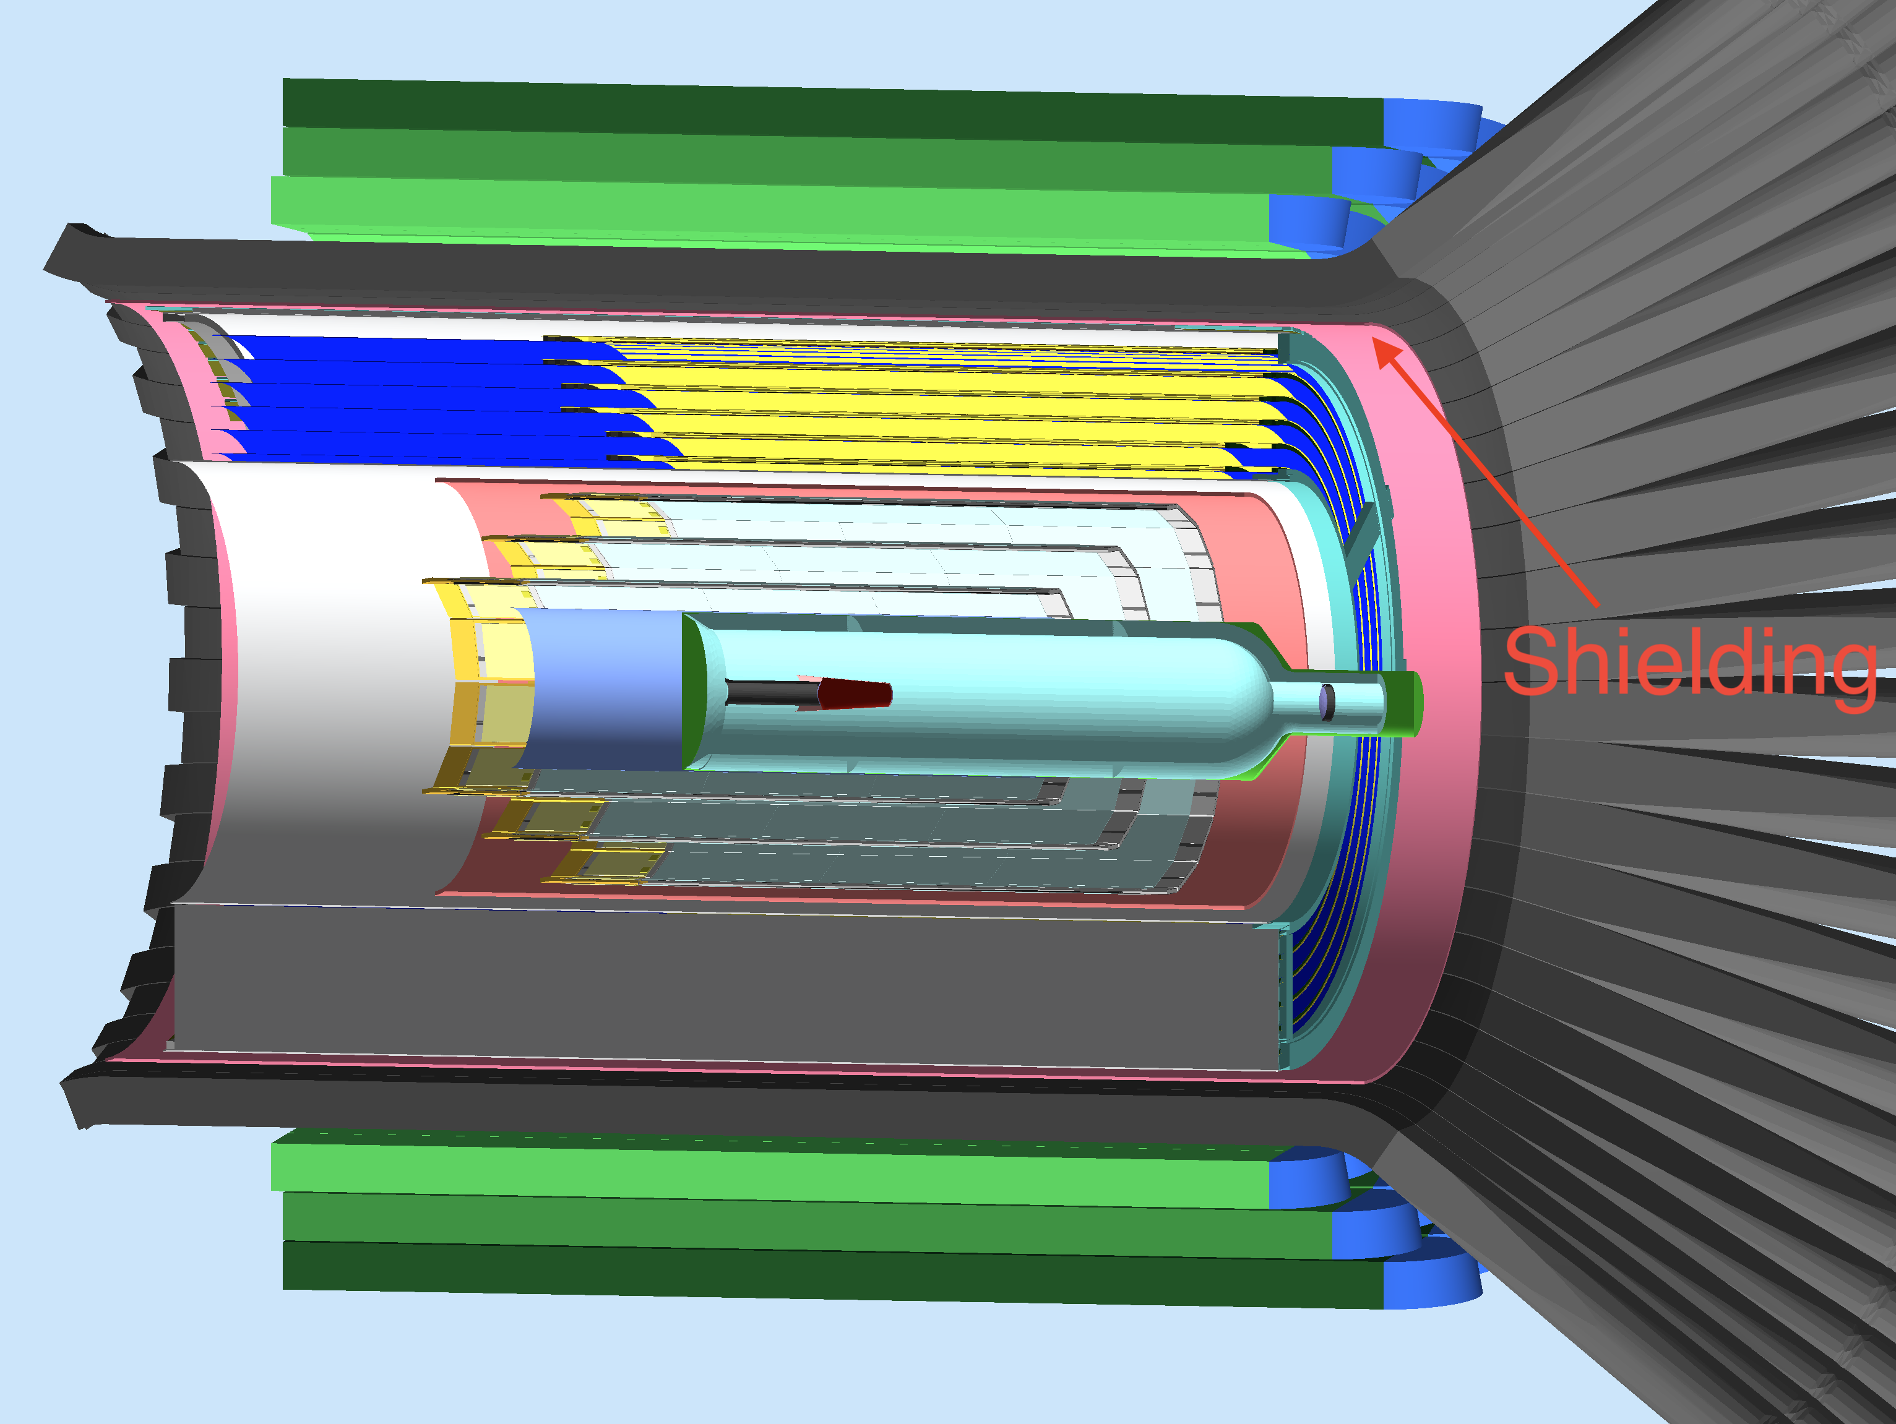

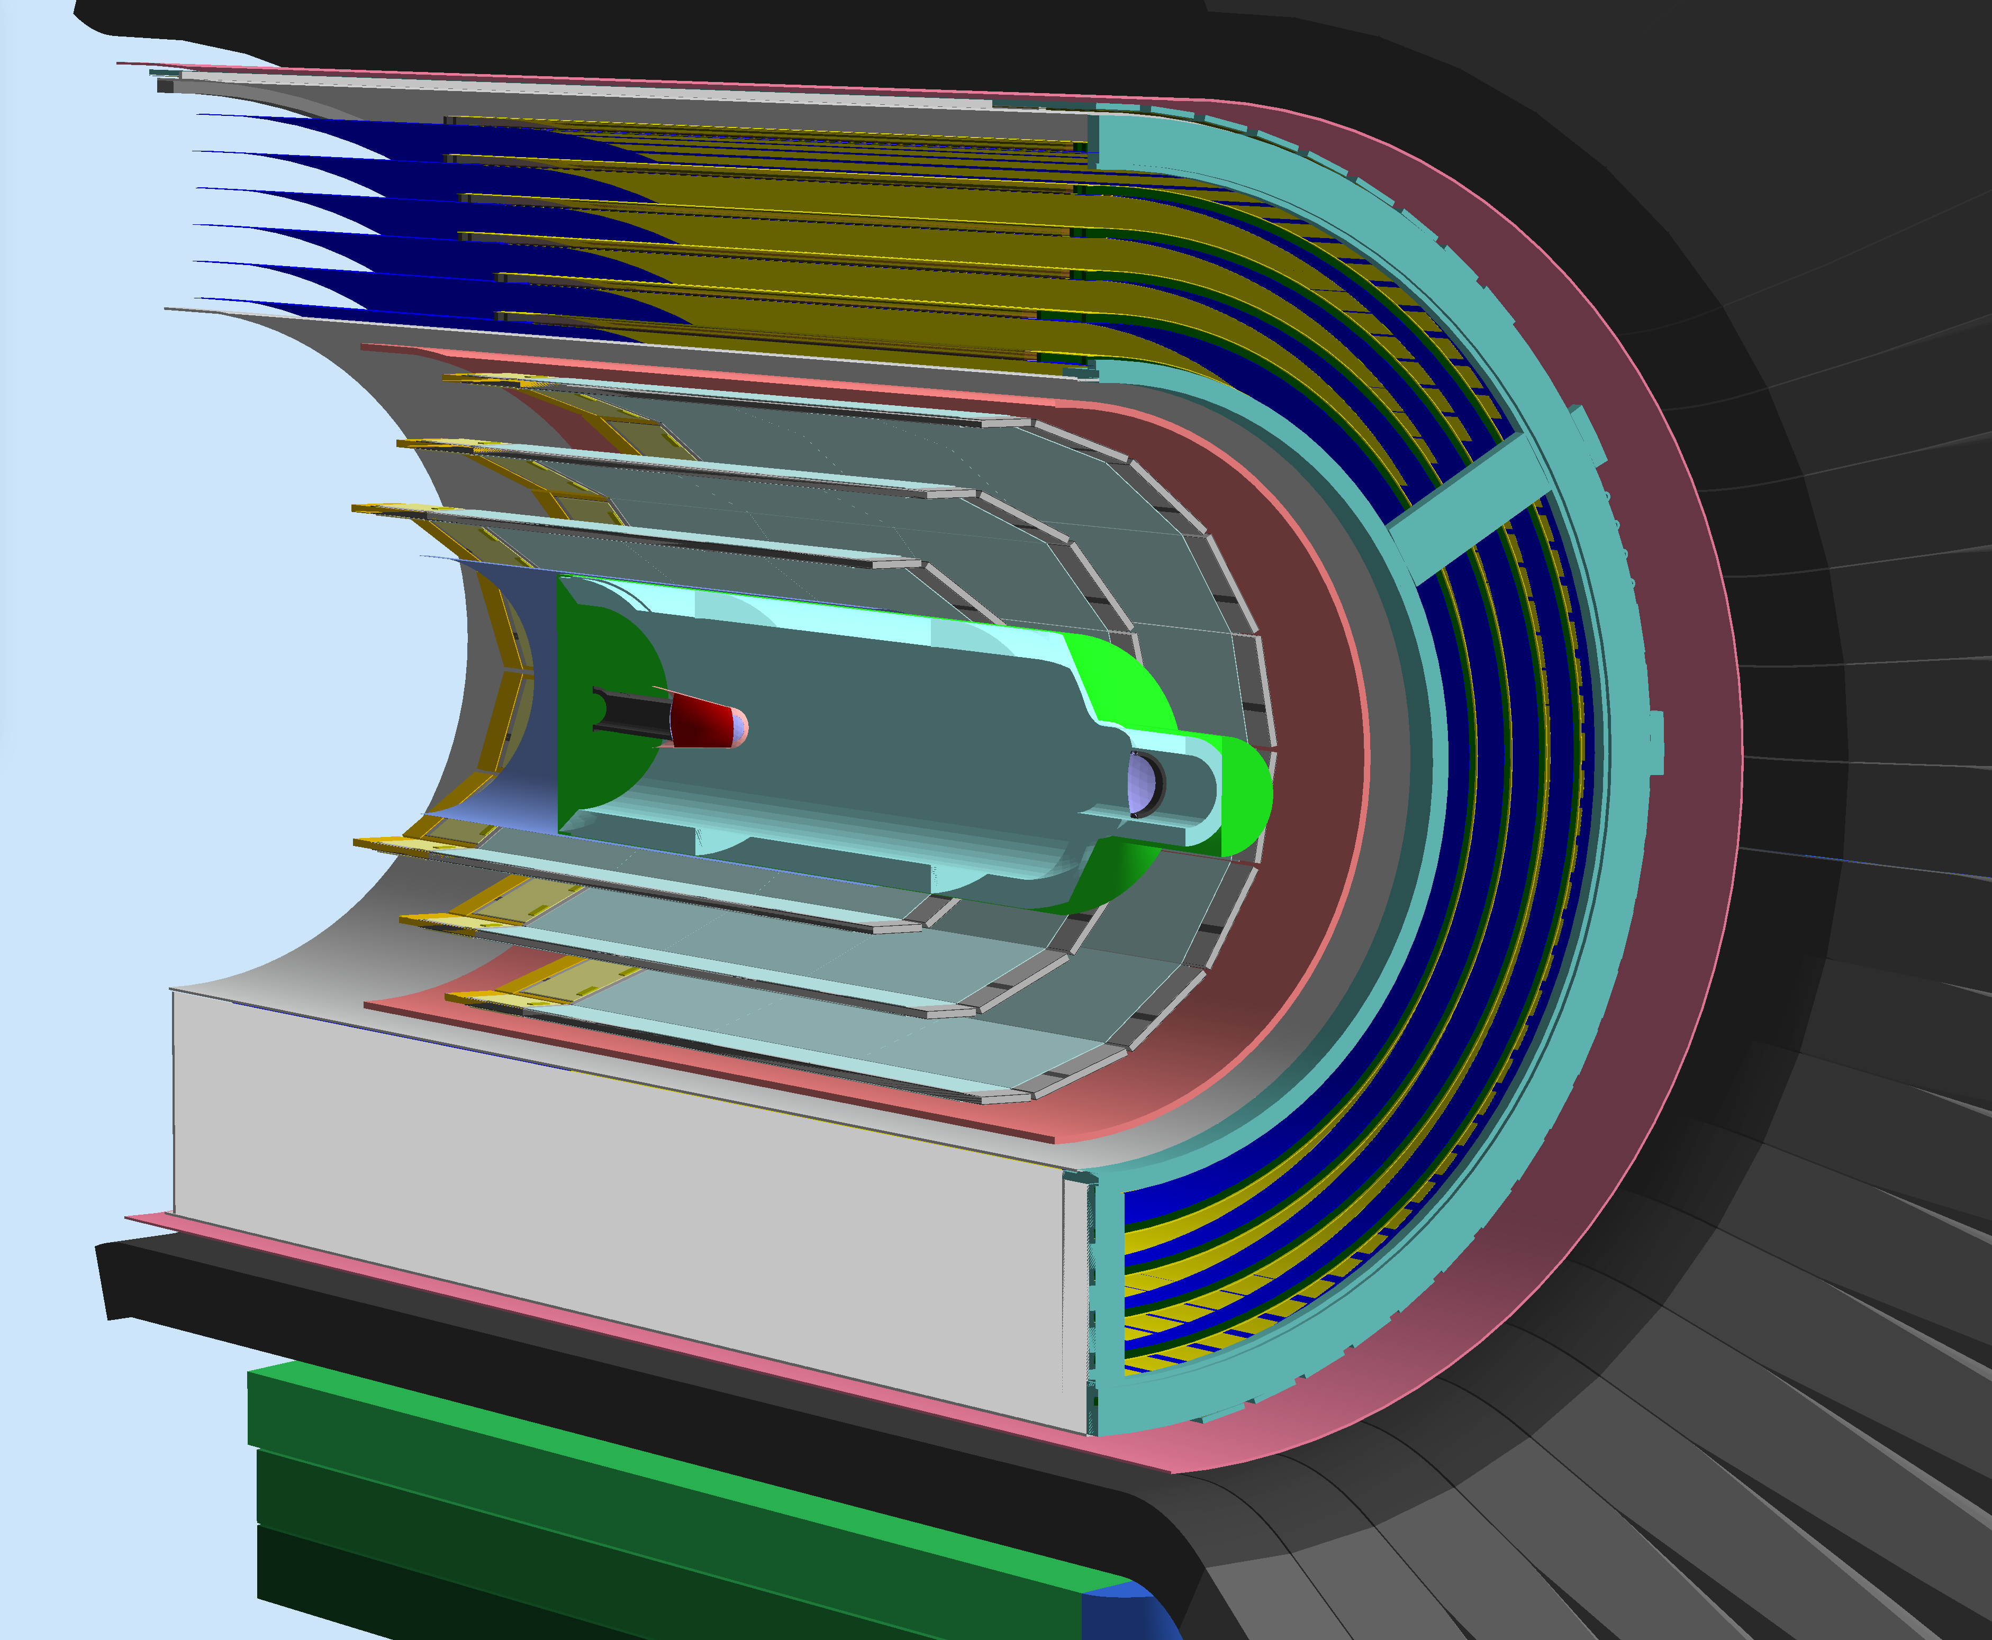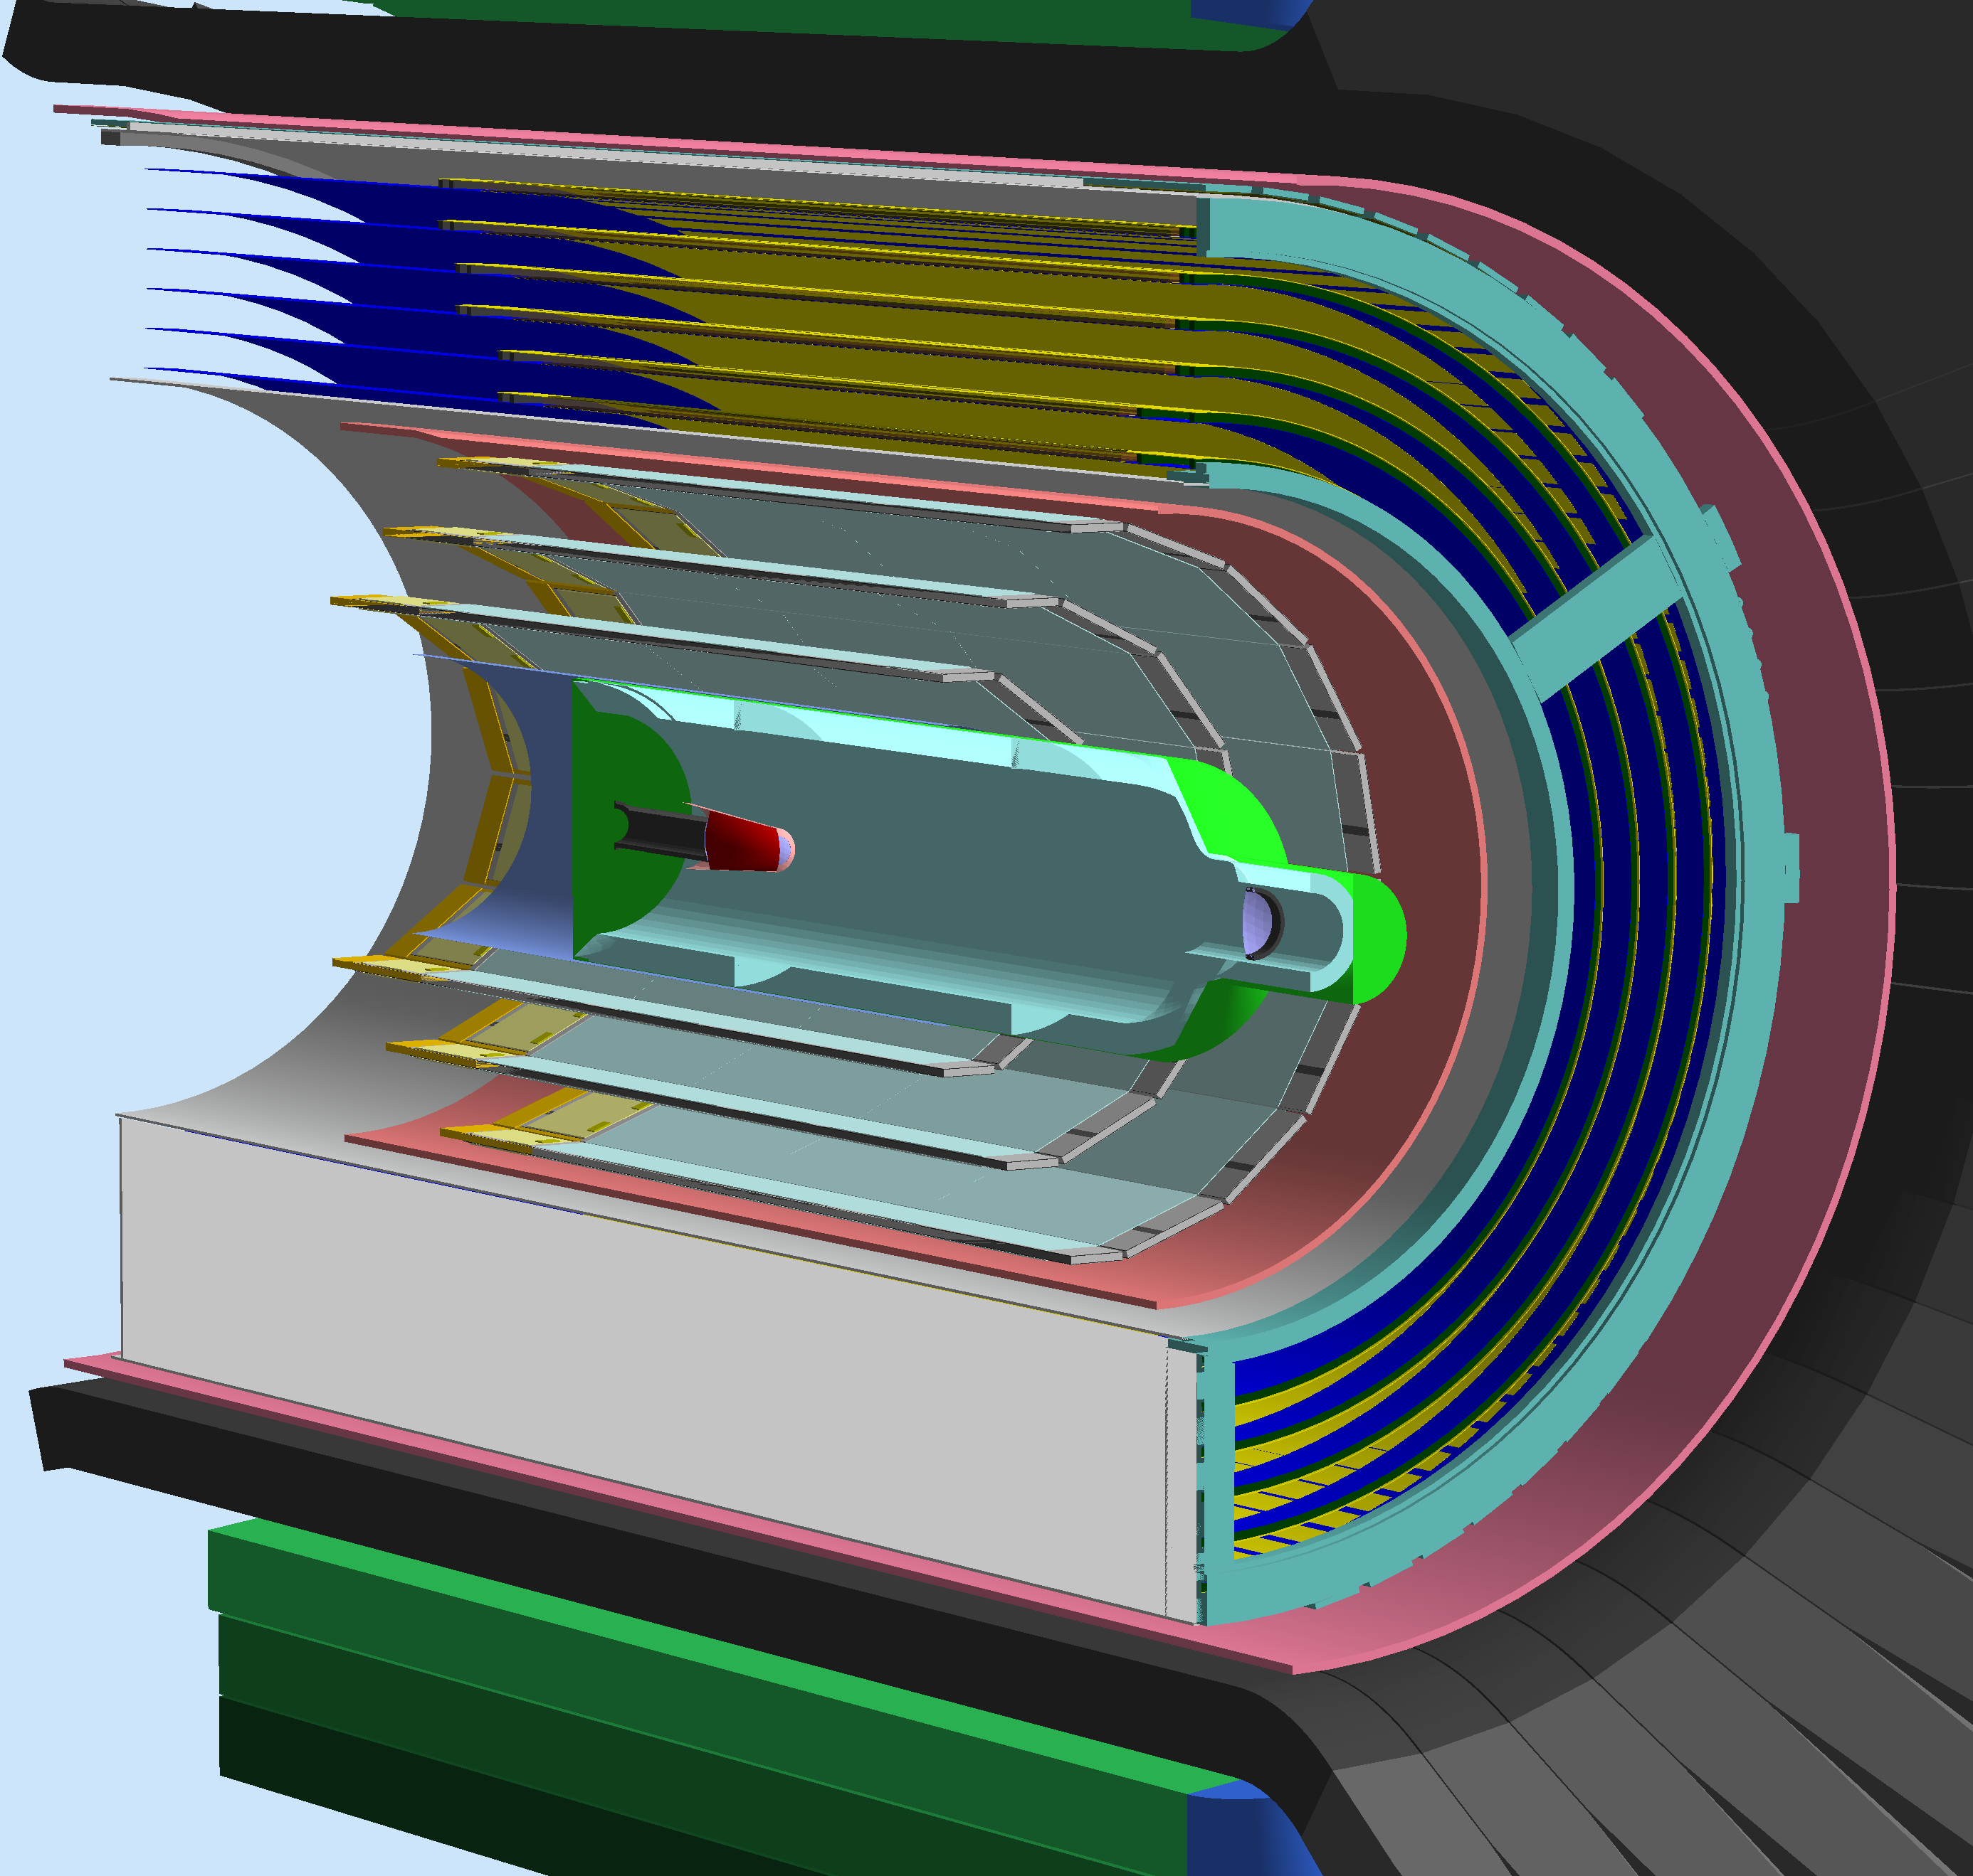

Figure 1. Top: A section of the CLAS12 Central Detector. The beam goes from left to right. The liquid-hydrogen target is at the center, surrounded by a 51-m-thick tungsten shield. The barrel silicon and micromegas trackers surround the target. An additional tungsten shield surrounds the tracker volume inside of the CTOF. Bottom left: 1-mm-thick configuration for the CTOF shield. Bottom right: 2-mm-thick configuration for the CTOF shield.

**Paddle Background Rates**

In Figure 2 (top) the total rates as a function of CTOF paddle number are presented for each of the shielding configurations. The bottom of this figure shows only the electromagnetic rates, showing that they make up most of these rates. All the shielding configurations do an increasingly good job at stopping a lot of these particles. However, see Figure 3, most of the rate was below the CTOF readout threshold.

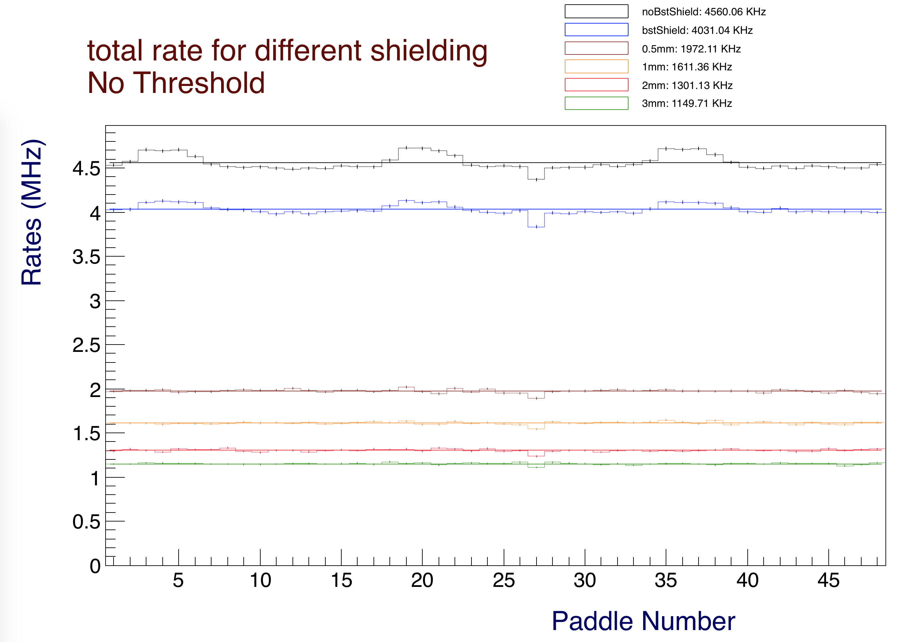

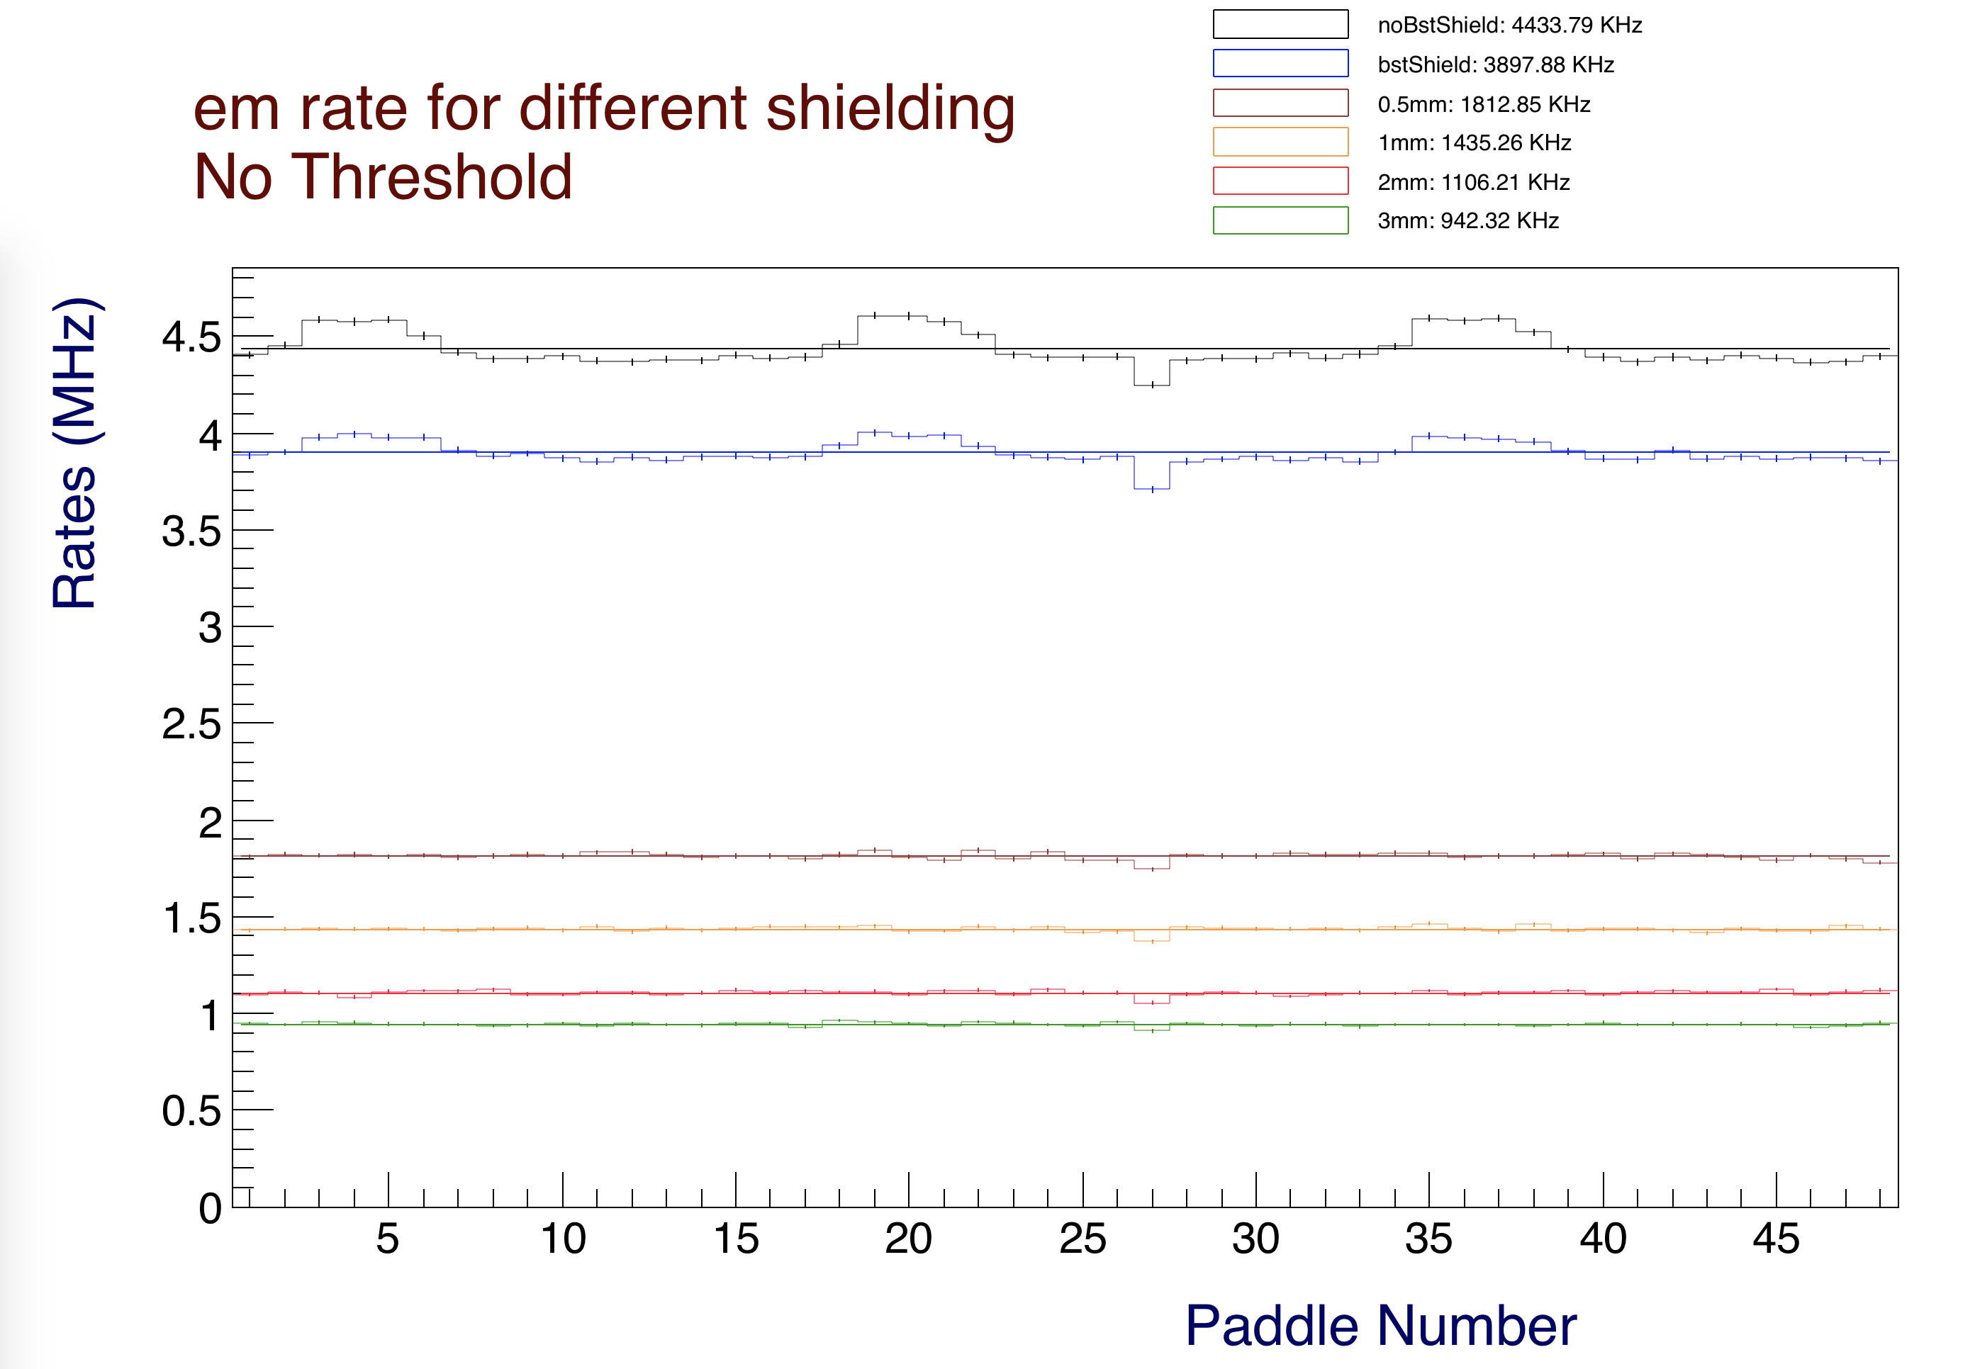

*Figure 2. Top: Rates for all particles as a function of paddle. The legend reports the average paddle rate in kHz. The total rate can be calculated multiplying these averages by the number of counters (48). For example, the total rate in CTOF for the configuration with the 51 m W shield before the BST is roughly 198 MHz. Bottom: lepton and gamma rates make up most of the CTOF rates. These plots are for the full nominal CLAS12 operating luminosity.*

In Figure 3 the total rates are shown with a 1 MeV energy threshold applied (the same as used for the detector readout). One can see that the various shielding configurations, while being able to reduce the low energy particle rates, actually produce additional higher-energy background.

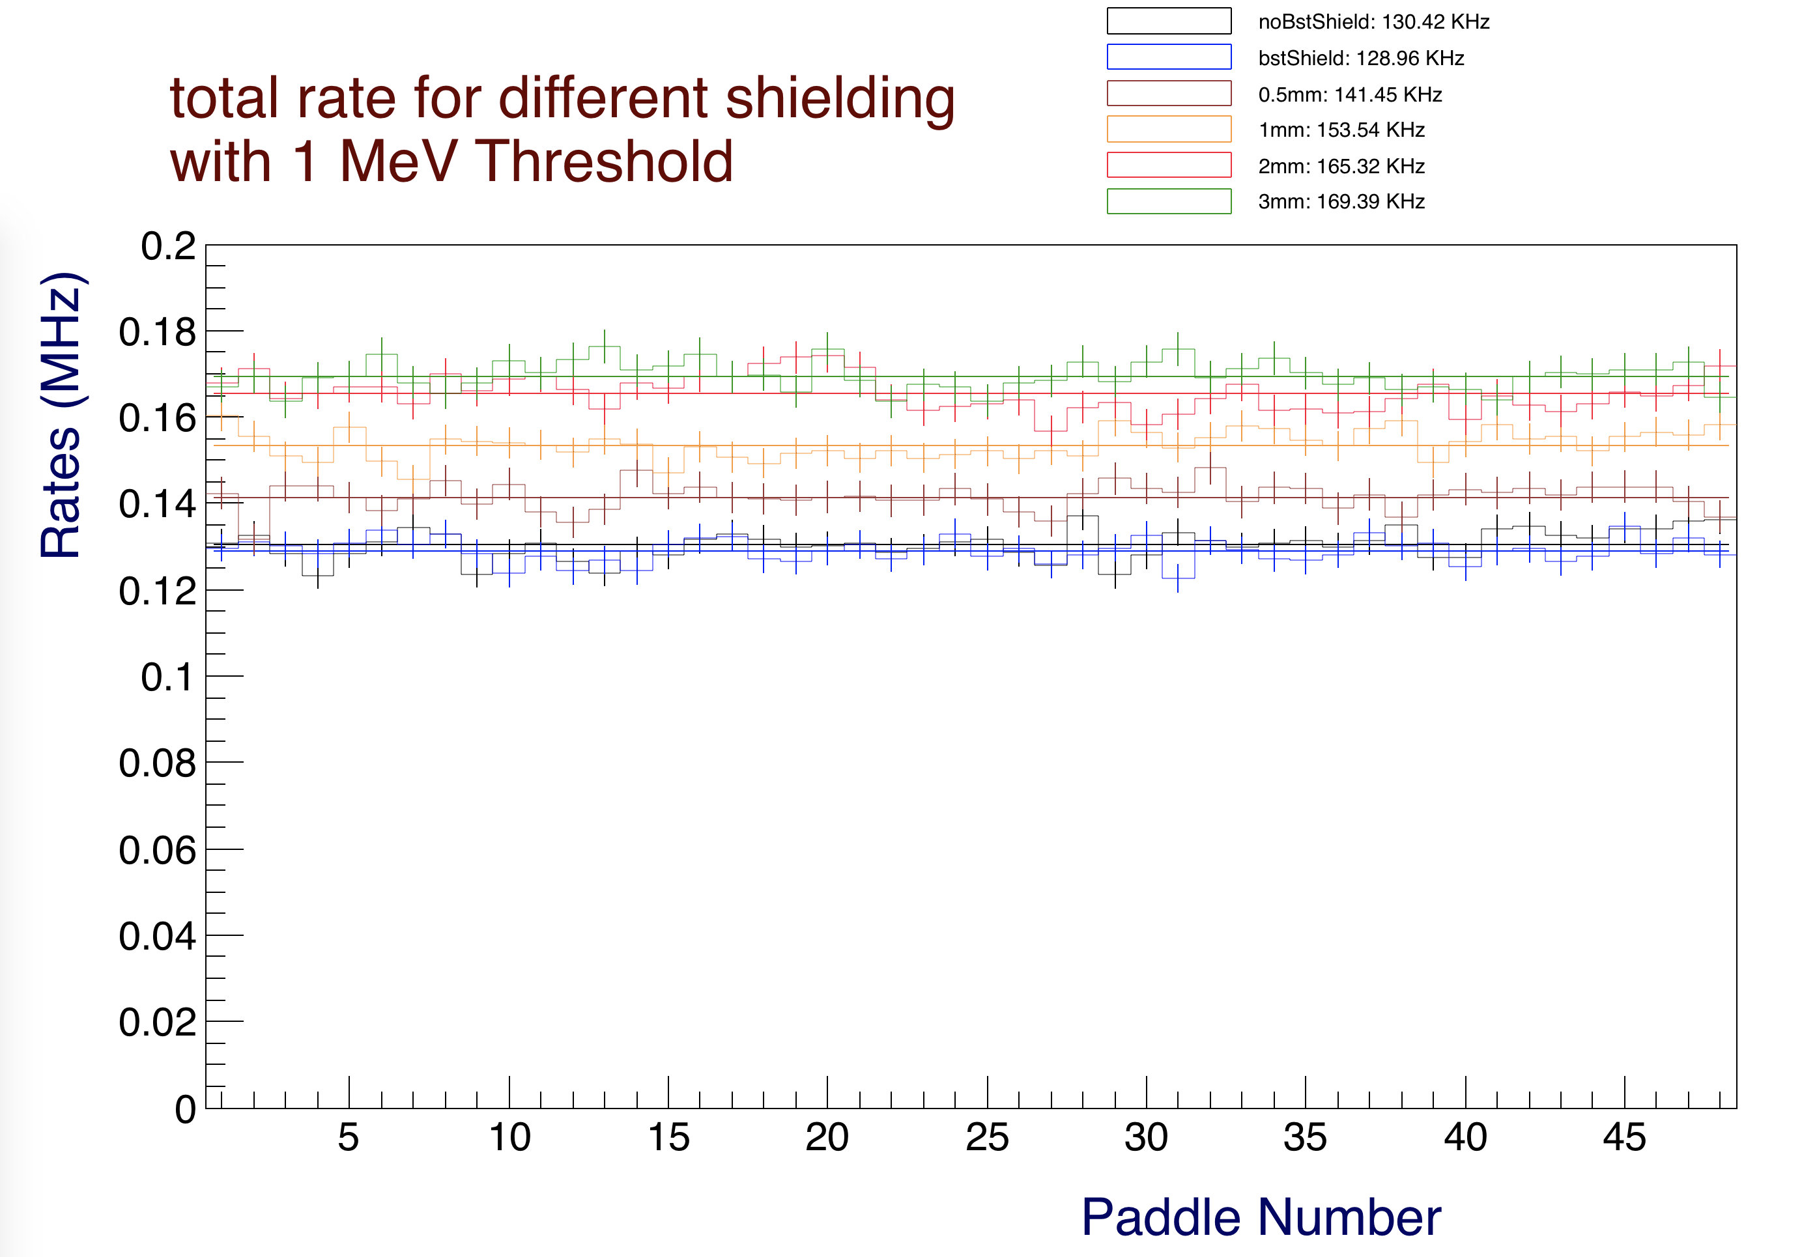

*Figure 3: Rates above 1 MeV of deposited energy showing that the shielding material increases the counter rates. This plot is for the full nominal CLAS12 operating luminosity.*

Figure 4 is shows that the background producing the above-threshold rates is composed equally by leptons and hadrons. The gamma rates above 1 MeV are negligible.

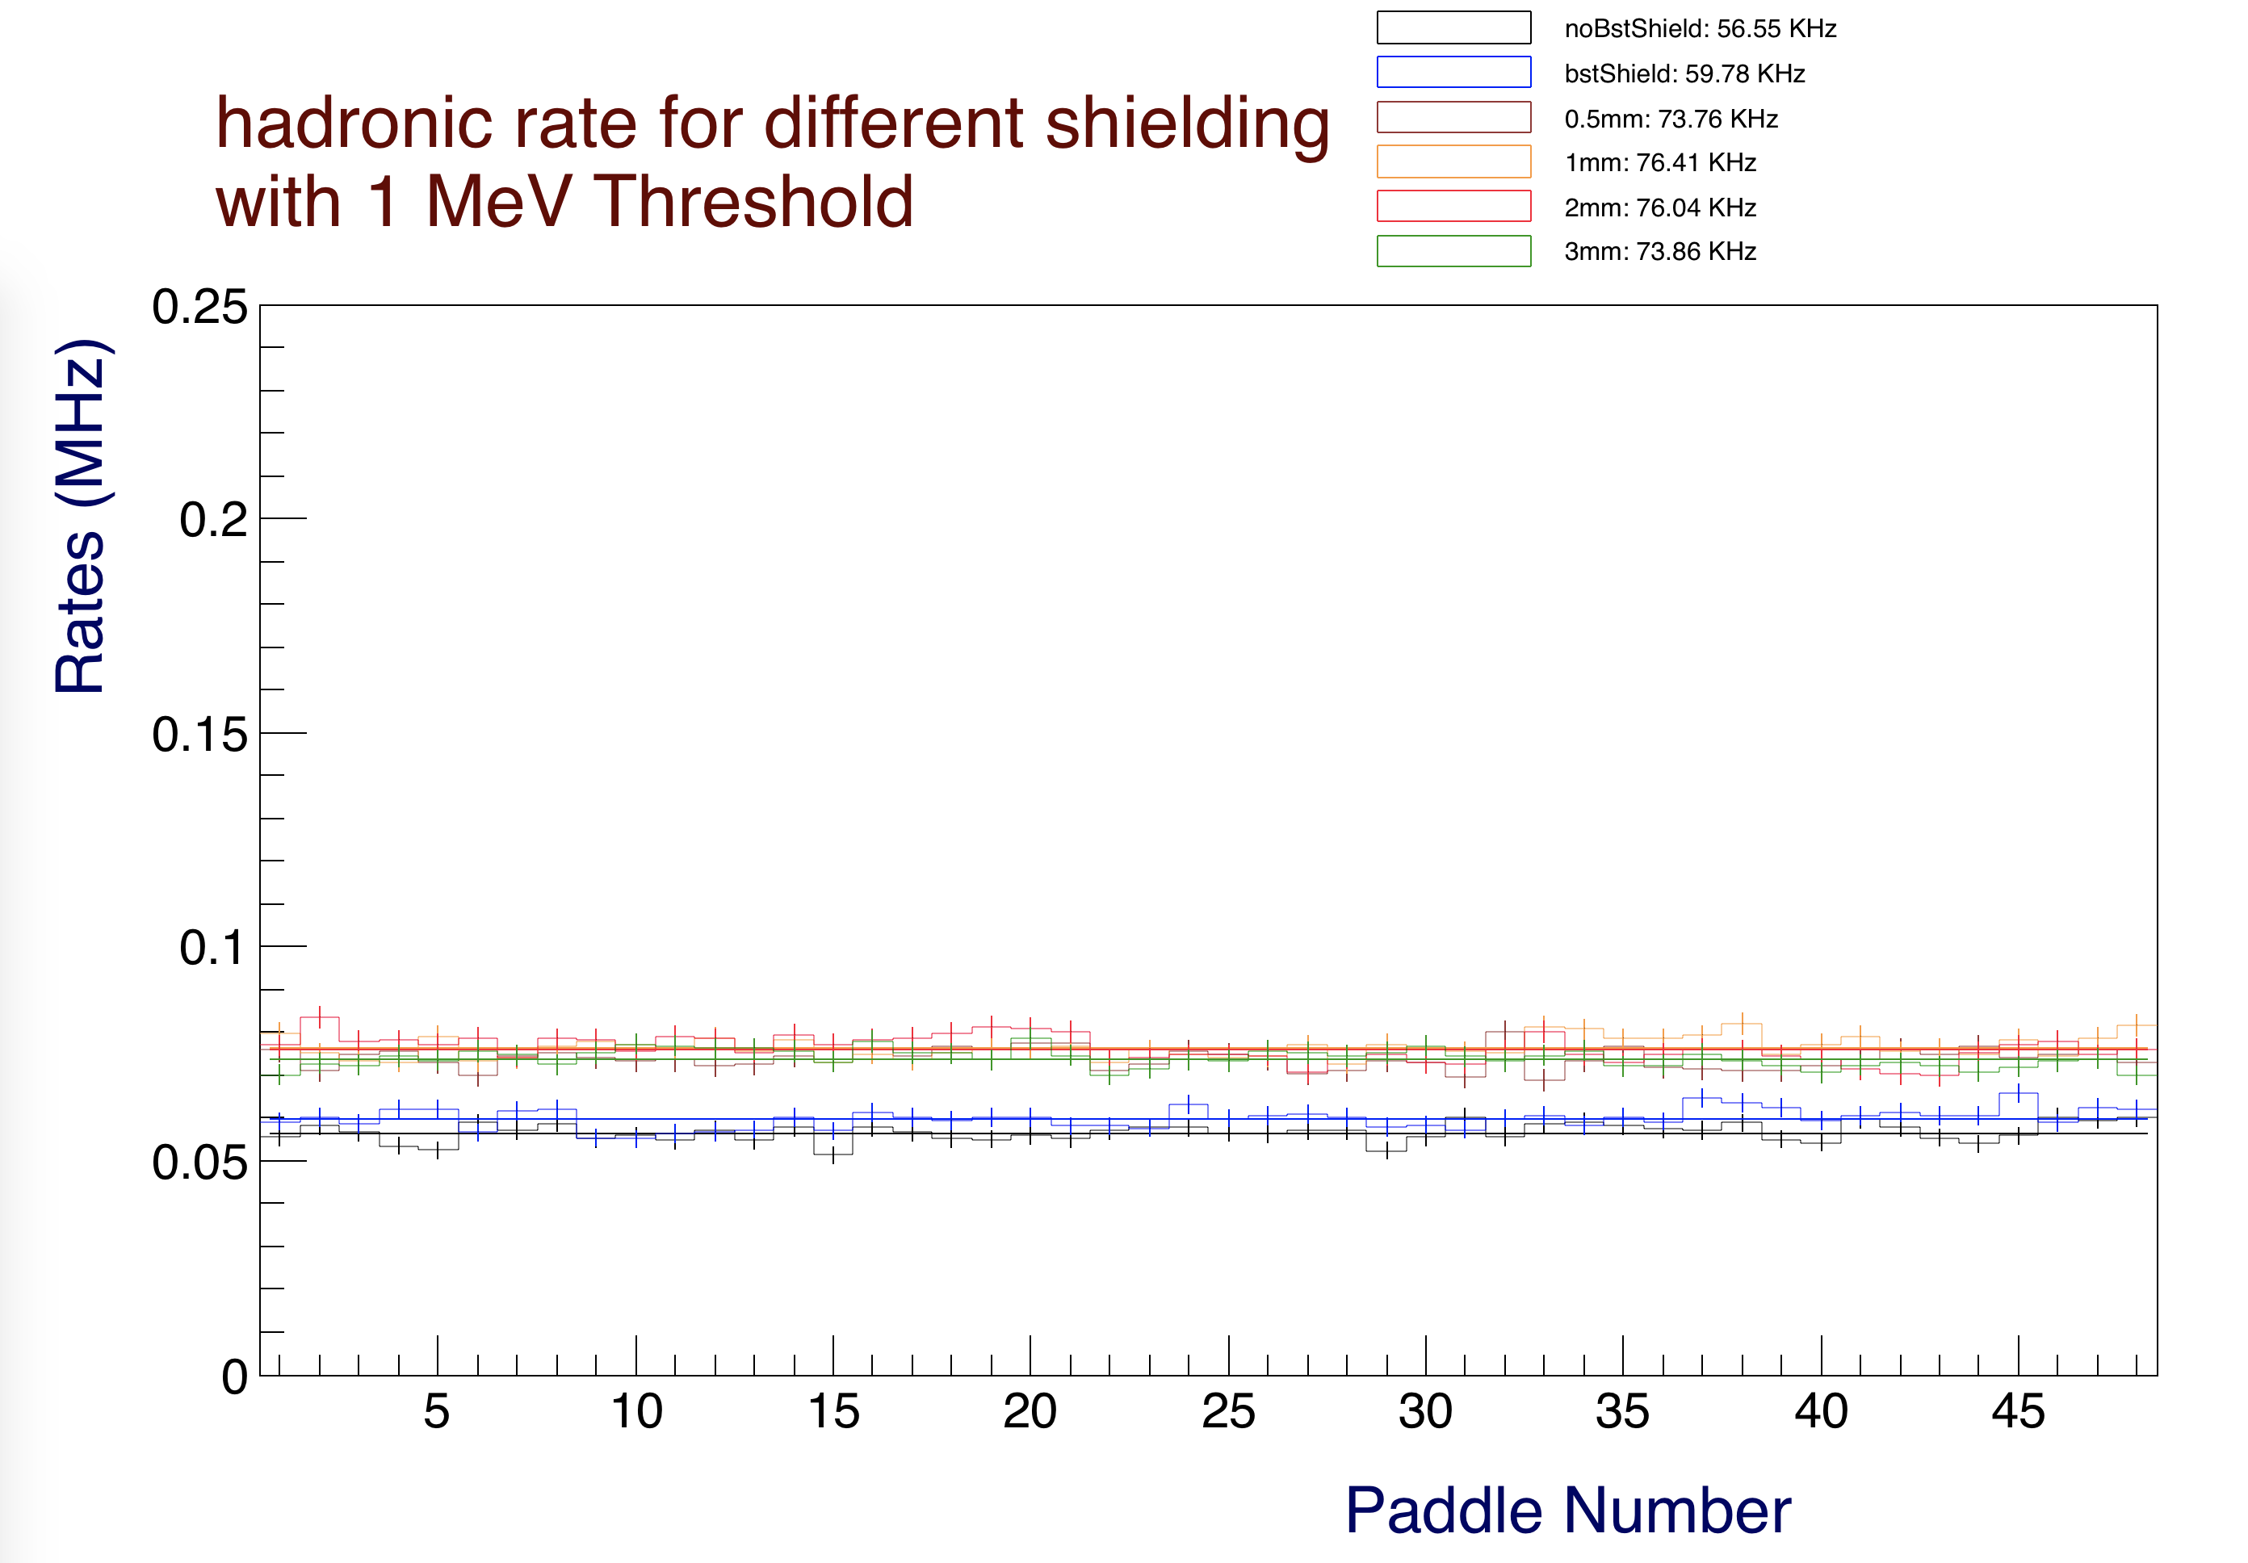

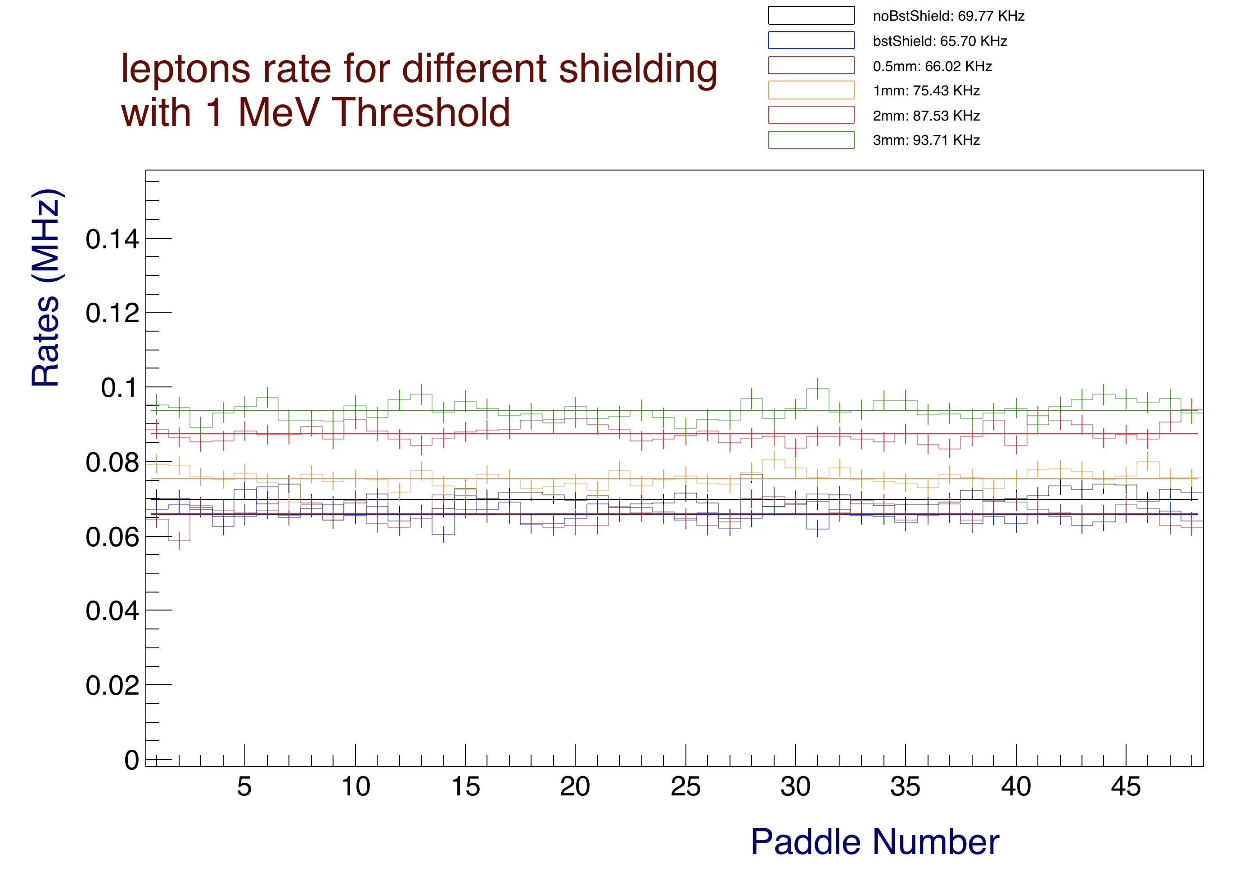

*Figure 4: CTOF hadron (top) and lepton (bottom) rates above 1 MeV of deposited energy. The gamma rates are reduced to below 3 kHz for all shielding configurations. These plots are for the full nominal CLAS12 operating luminosity.*

**Deposited Energy Rates**

In Figure 5 the total deposited energy is shown. The particles generated by the various shielding configurations have a peak of energy deposited between 5 and 10 MeV. These are the particles either generated in the shields, or that the shield cannot stop.

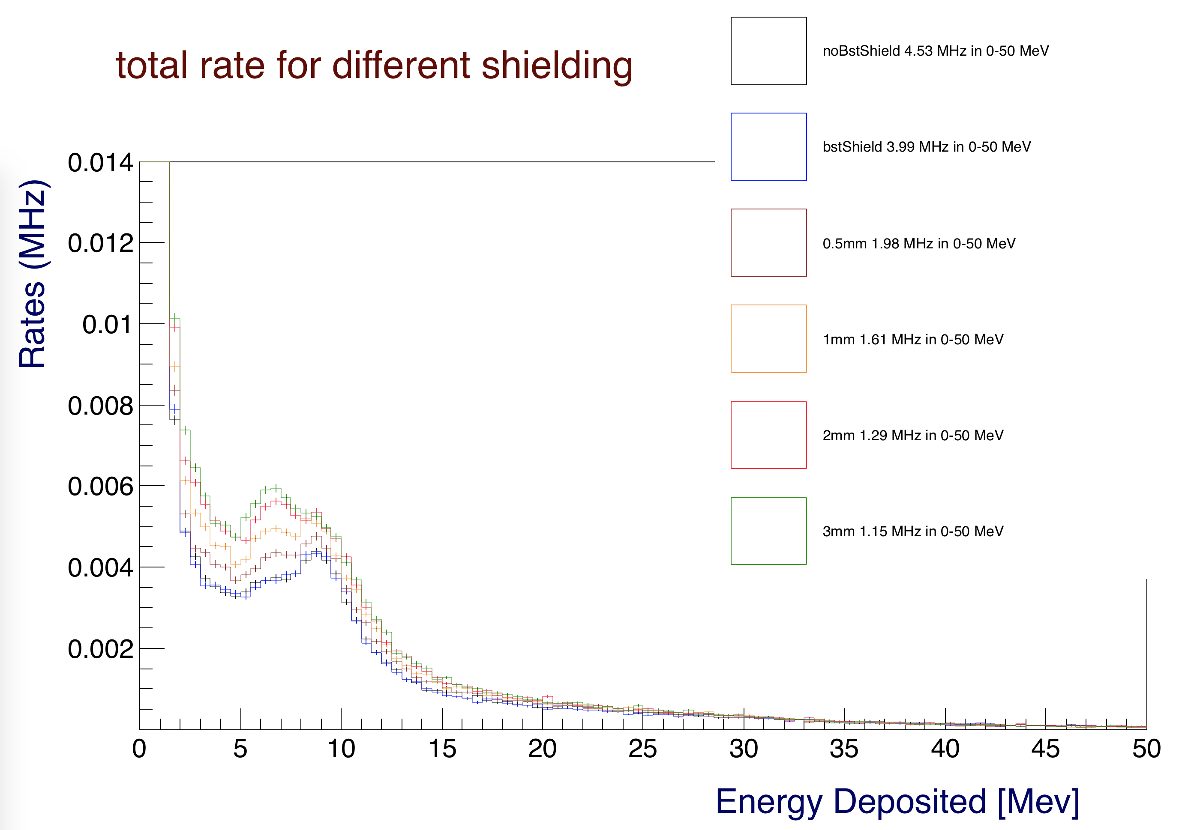

*Figure 5: Single counter deposited energy spectra for the different shielding configurations. This plot is for the full nominal CLAS12 operating luminosity.*

In Figure 6 the energy deposited below 120 keV is plotted. This is the energy range where the shields are more effective and can reduce rates by a factor of 3 or more.

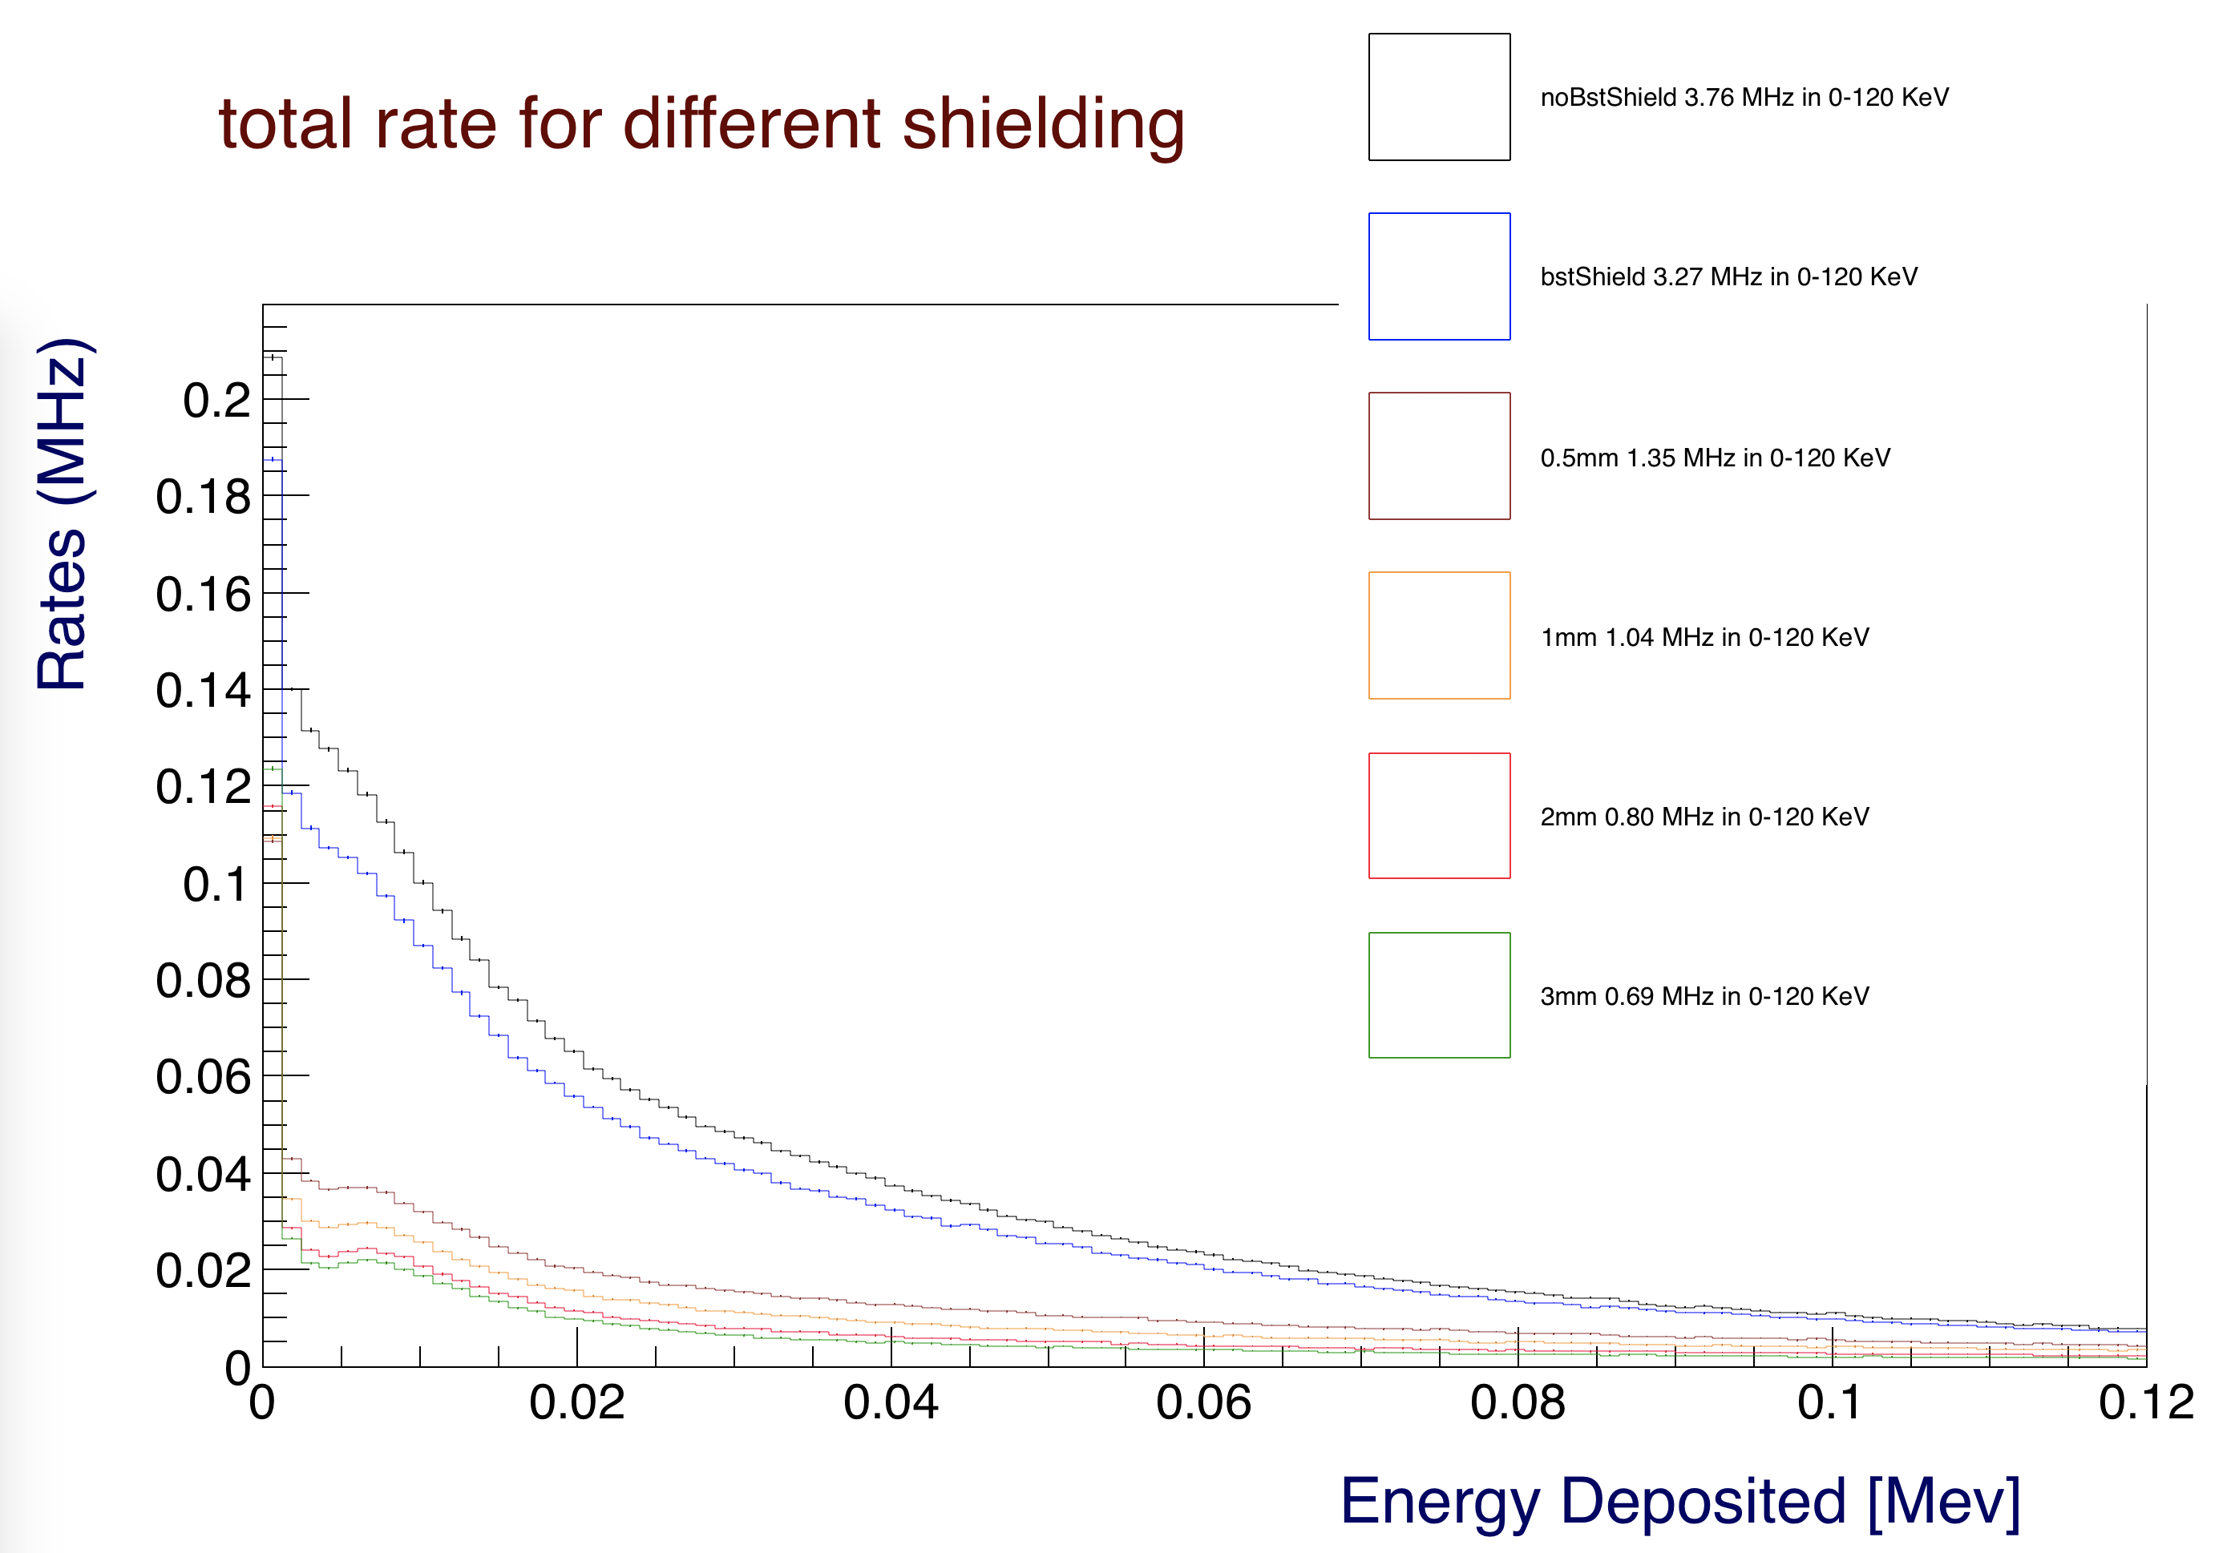

*Figure 6: Single counter deposited energy for the different shielding configurations, up to 120 keV. This plot is for the full nominal CLAS12 operating luminosity.*

**Background Origin**

The transverse vs. longitudinal vertex of the origin coordinates of the particles hitting CTOF without and with a 1 MeV energy threshold is plotted in Figures 7, 8, and 9 for the BST shield, 0.5 mm and 3 mm tungsten shields, respectively. By comparing the three pictures it is apparent that additional shielding, while stopping low energy particles, also creates background rates.

The one dimensional transverse vertex distributions for all configurations are shown in Figure 9b.

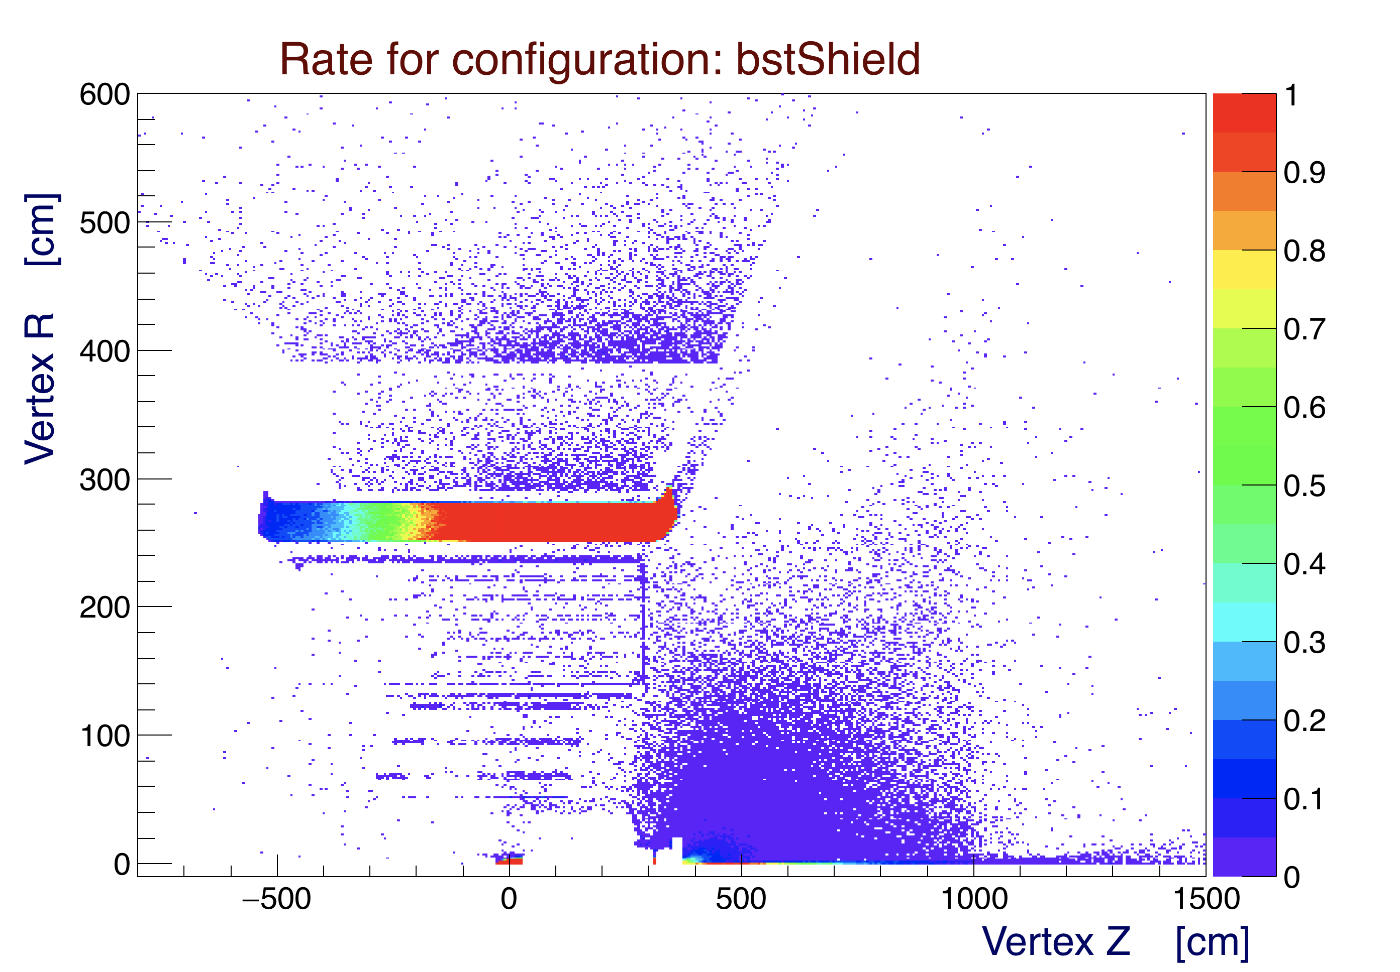

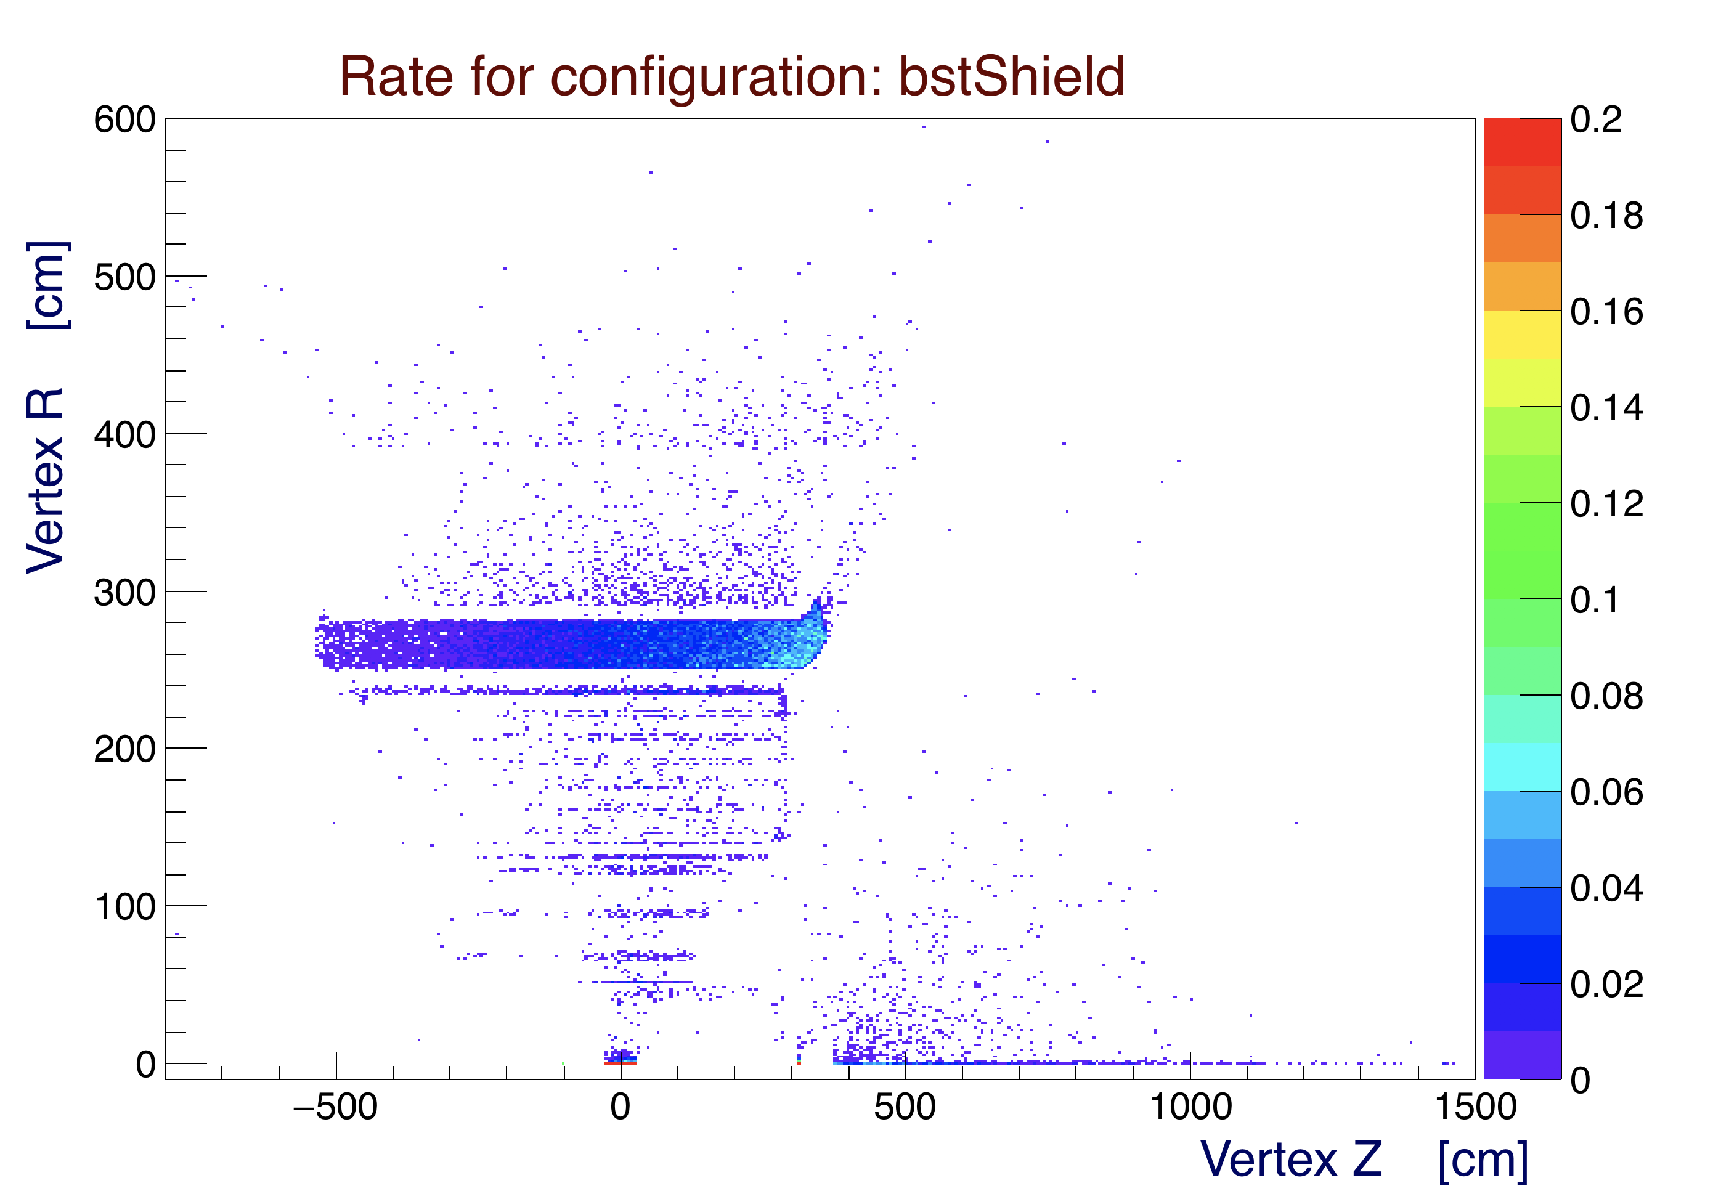

*Figure 7: Transverse vs. longitudinal vertex of particles hitting CTOF. The z-scale maximum is fixed at 1 kHz (top) and 200 Hz (bottom). This is the configuration with the BST shielding only (51-m-thick tungsten). Top: no threshold. Bottom: 1 MeV threshold.*

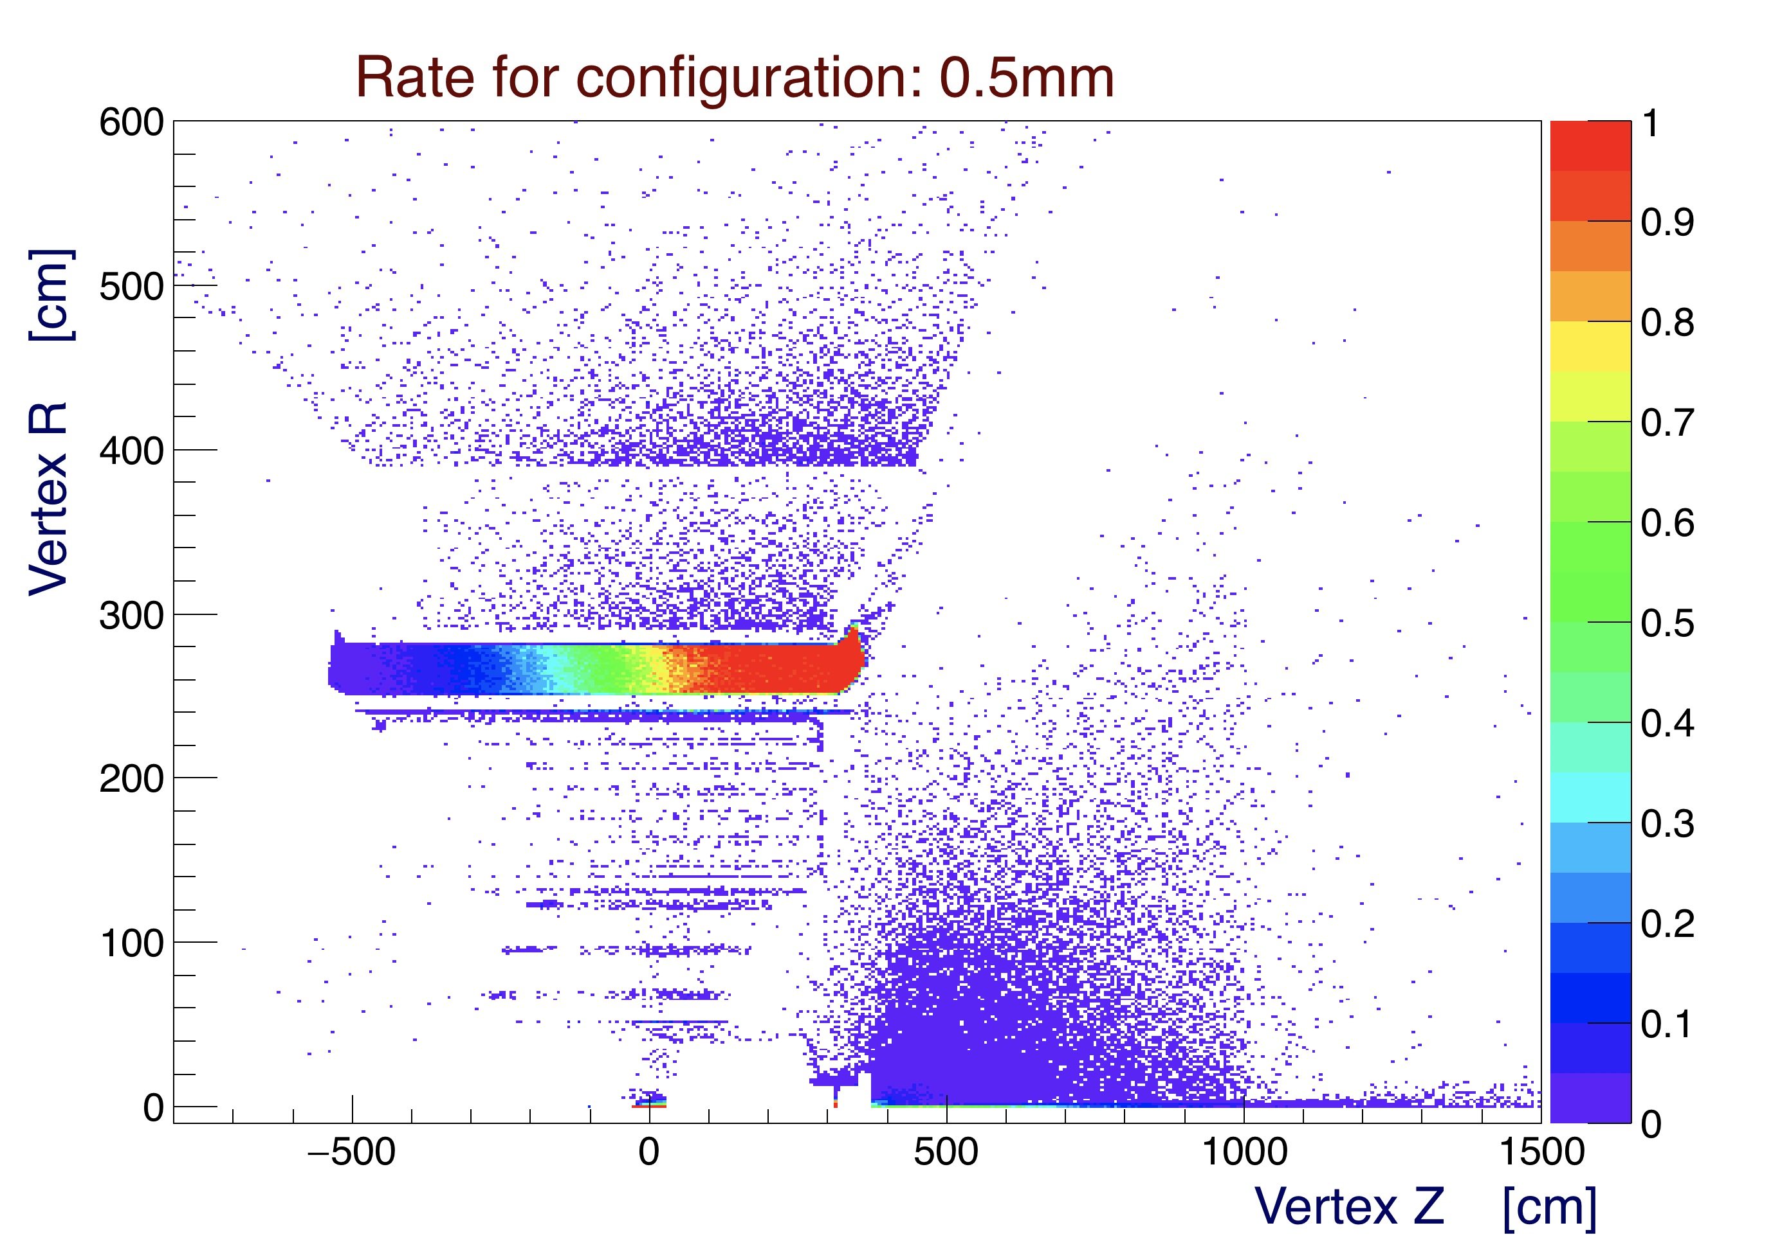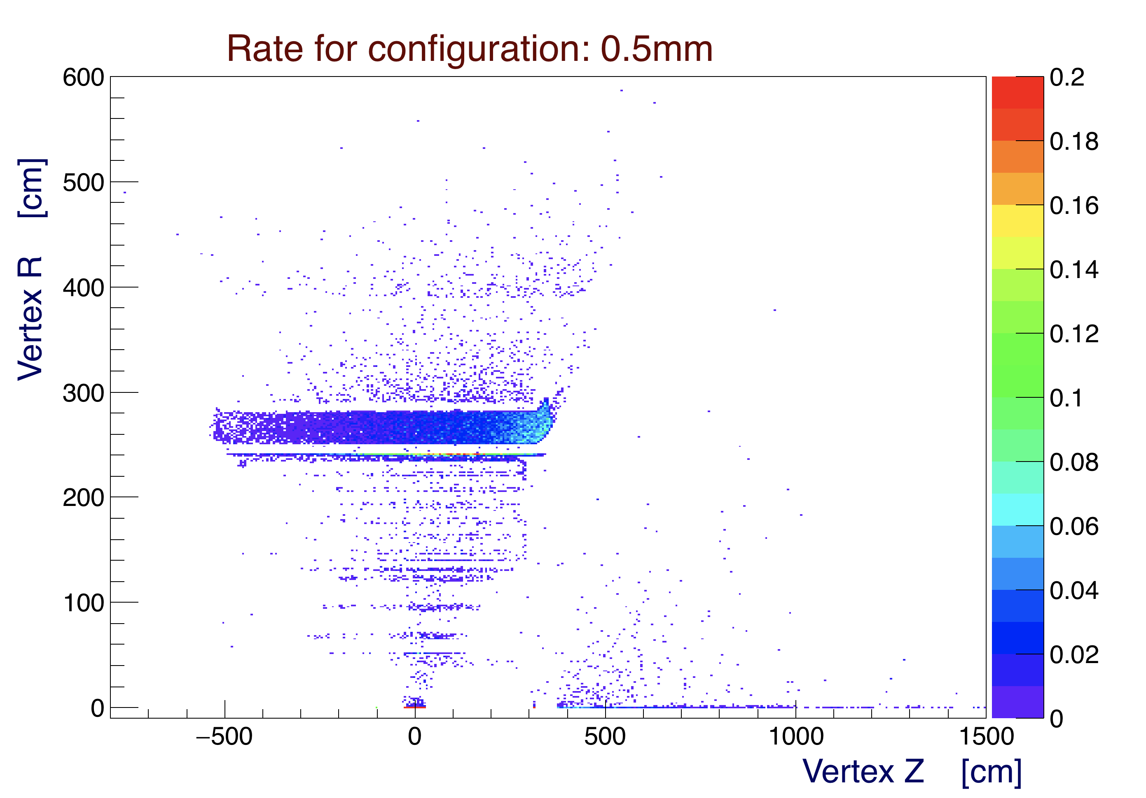

*Figure 8: Transverse vs. longitudinal vertex of particles hitting CTOF. The z-scale maximum is fixed at 1 kHz (top) and 200 Hz (bottom). An additional 0.5 mm tungsten shield is added between the BMT and CTOF. It becomes a source of background. Top: no threshold. Bottom: 1 MeV threshold.*

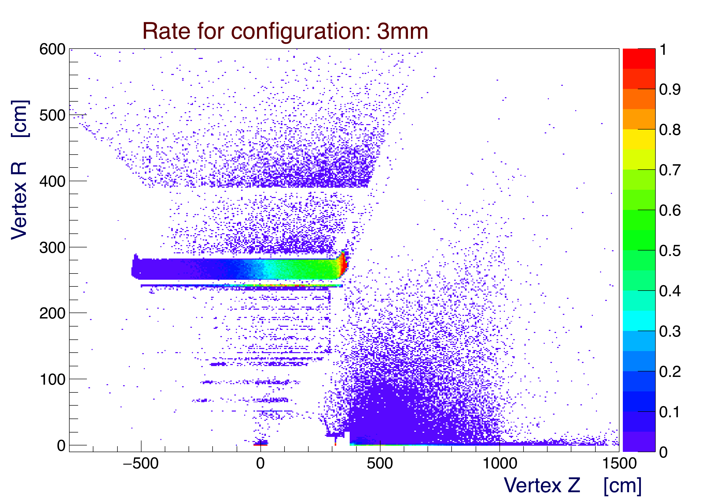

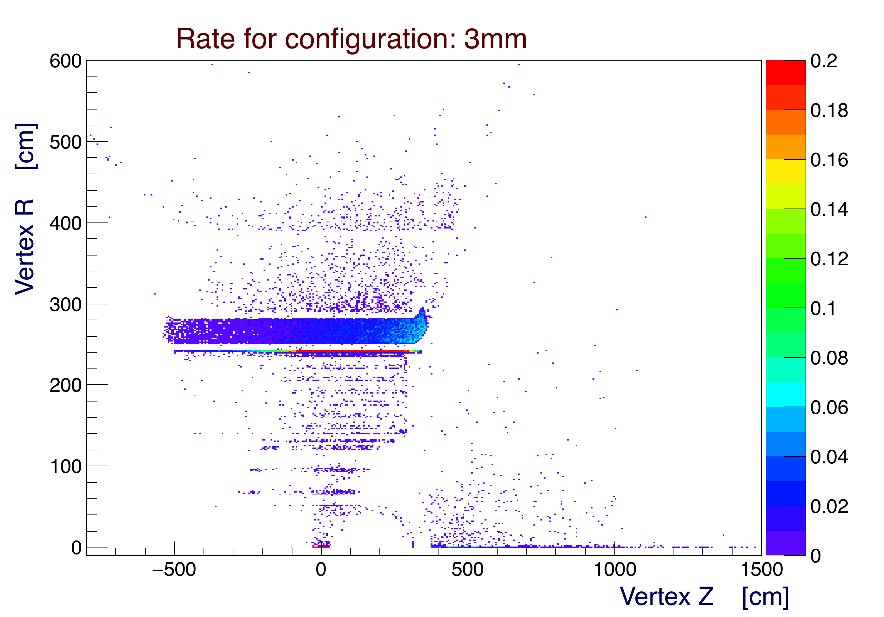

*Figure 9: Transverse vs. longitudinal vertex of particles hitting CTOF. The z-scale maximum is fixed at 1 kHz (top) and 200 Hz (bottom). A 3 mm tungsten shield is added between the BMT and CTOF. It becomes a source of background. Top: no threshold. Bottom: 1 MeV threshold.*

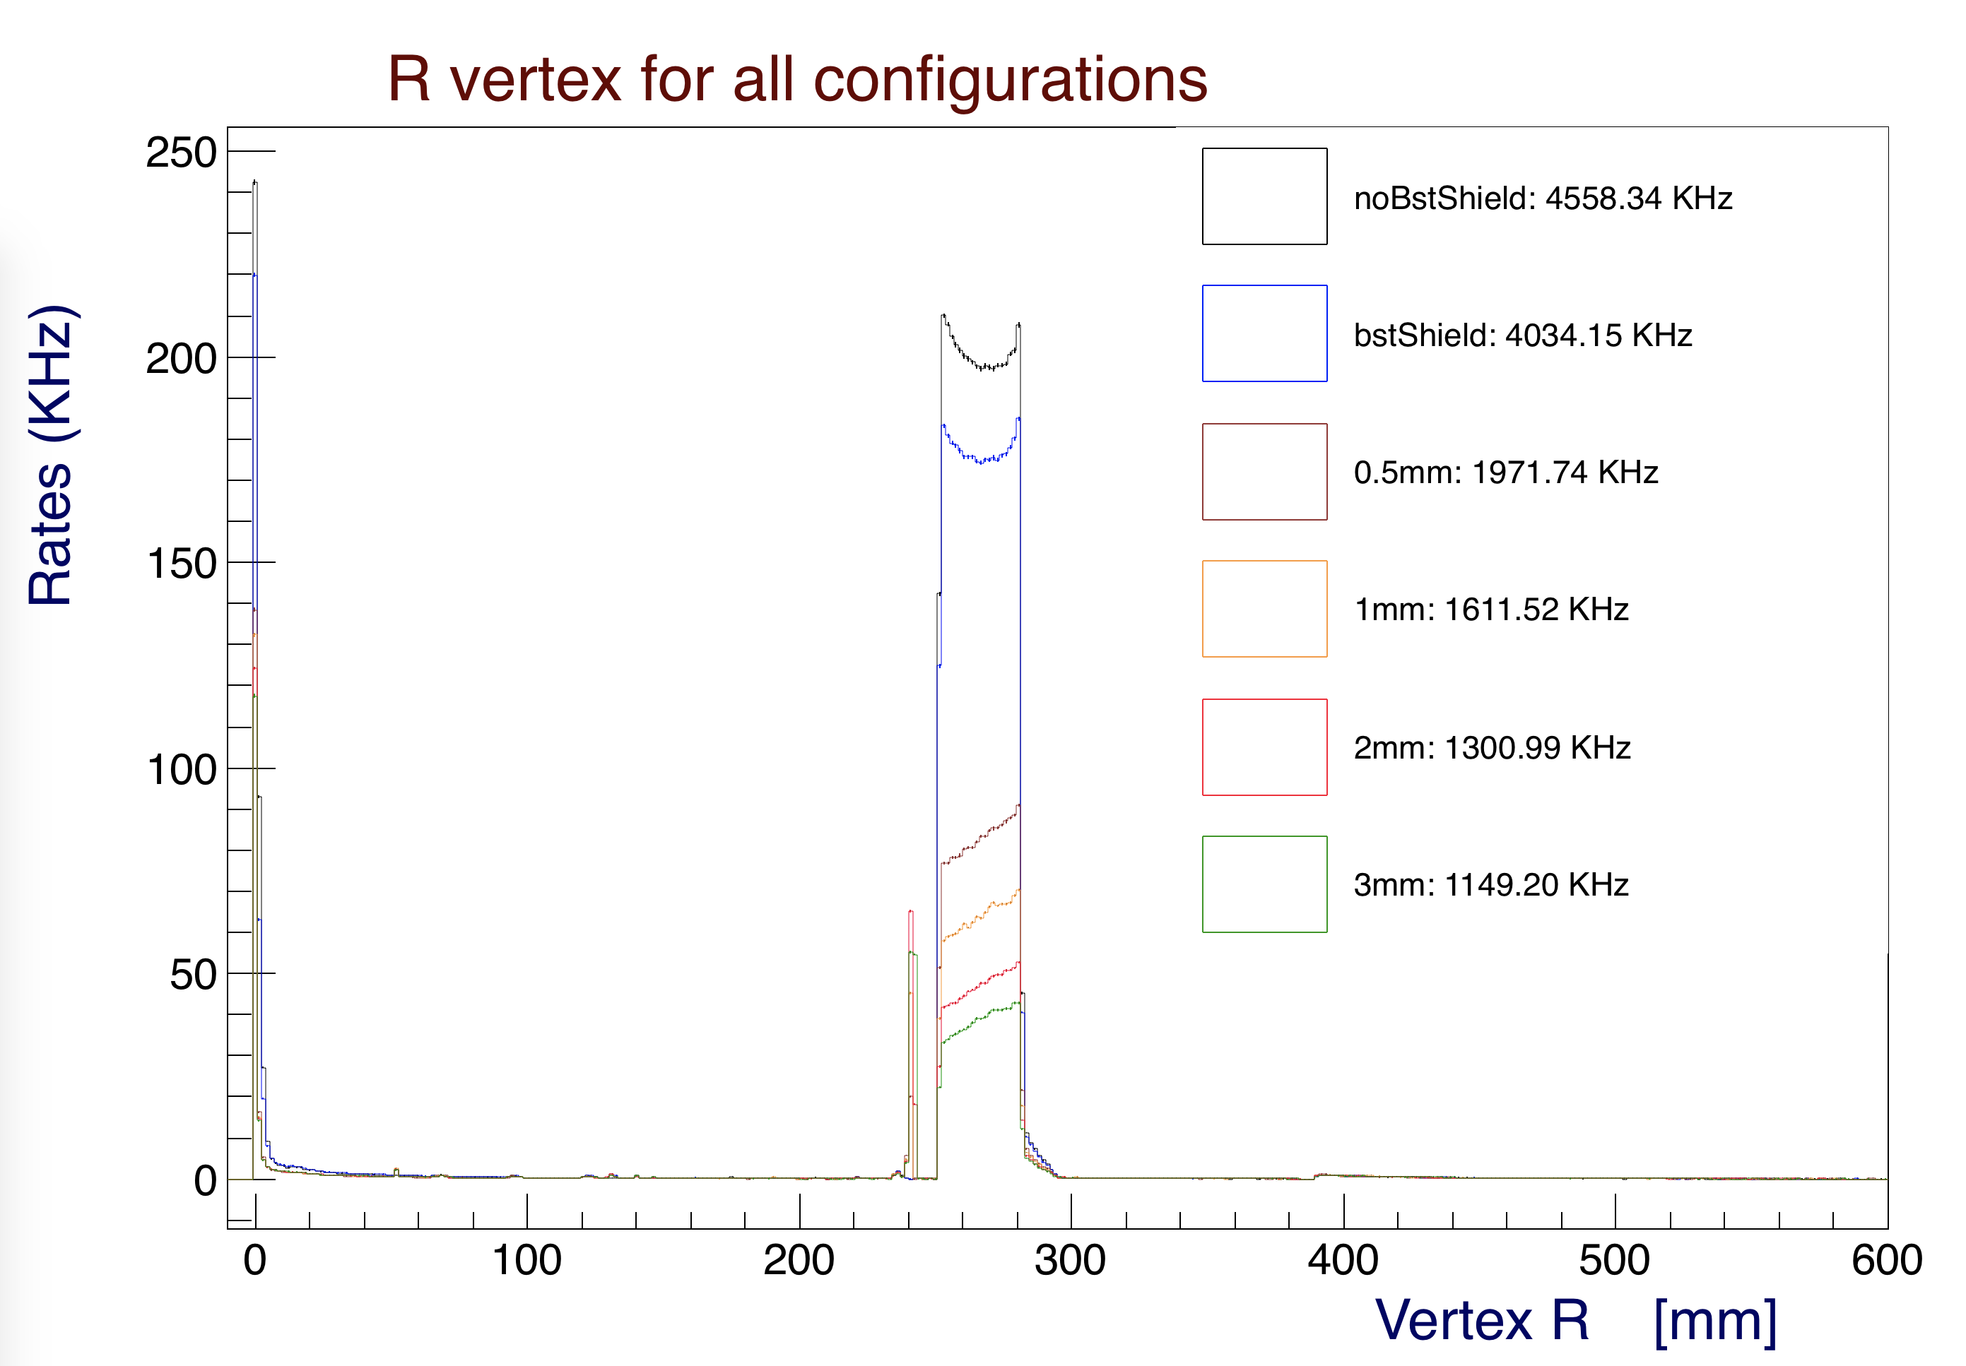

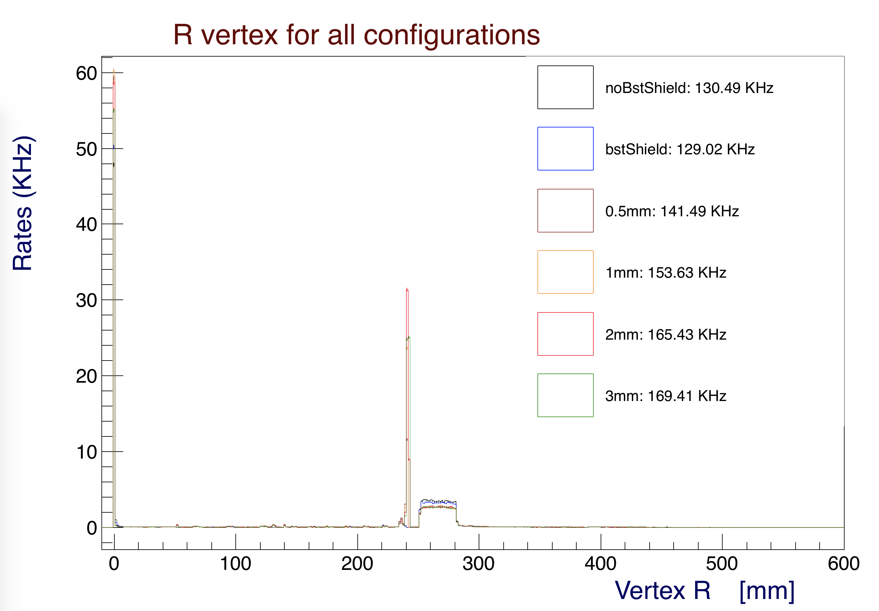

*Figure 9b: Single counter transverse vertex of particles hitting CTOF. Top: no threshold. Bottom: 1 MeV threshold. The shield appears to become a major contributor to the background.*

**Particle Momenta**

The particle rates as a function of momentum are shown in Figures 10, 11, and 12 for the BST shield, 0.5 mm, and 3 mm tungsten shields, respectively. It is apparent that additional shielding, while stopping low energy particles, also creates background rates. By comparing the BST shield with the 3 mm shield, one can see a 3-fold increase of lepton rates and about a 2-fold increase in the proton and neutron rates. The rates are zoomed in between the momentum range 0-2 MeV in Figures 13, 14, and 15 for the same configurations.

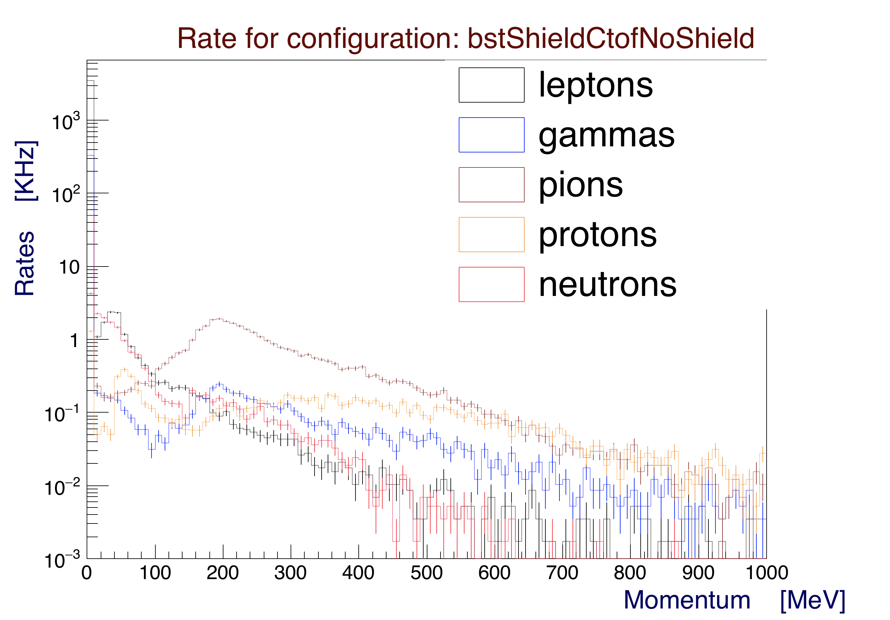

*Figure 10: Single counter rates as a function of momentum for particles hitting CTOF. This is the configuration with the BST shielding only (51-m-thick tungsten). This plot is for the full nominal CLAS12 operating luminosity.*

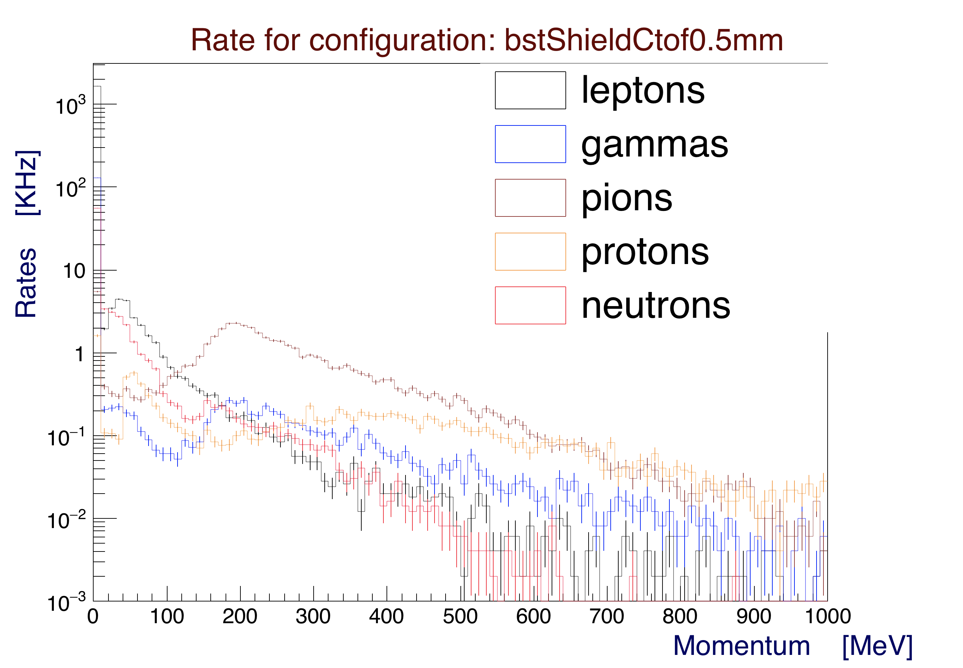

*Figure 11: Single counter rates as a function of momentum for particles hitting CTOF. The additional 0.5 mm tungsten shield is added between the BMT and CTOF. It increases background rates, in particular for leptons, protons, and neutrons. This plot is for the full nominal CLAS12 operating luminosity.*

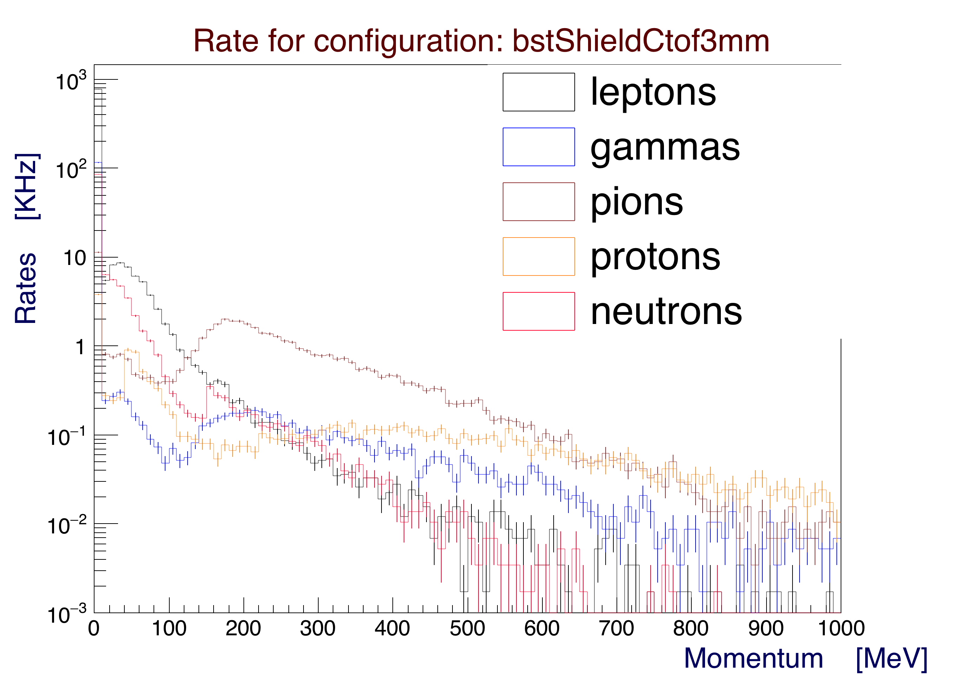

*Figure 12: Single counter rates as a function of momentum for particles hitting CTOF. The additional 3 mm tungsten shield is added between the BMT and CTOF. It increases background rates, in particular for leptons, protons, and neutrons. This plot is for the full nominal CLAS12 operating luminosity.*

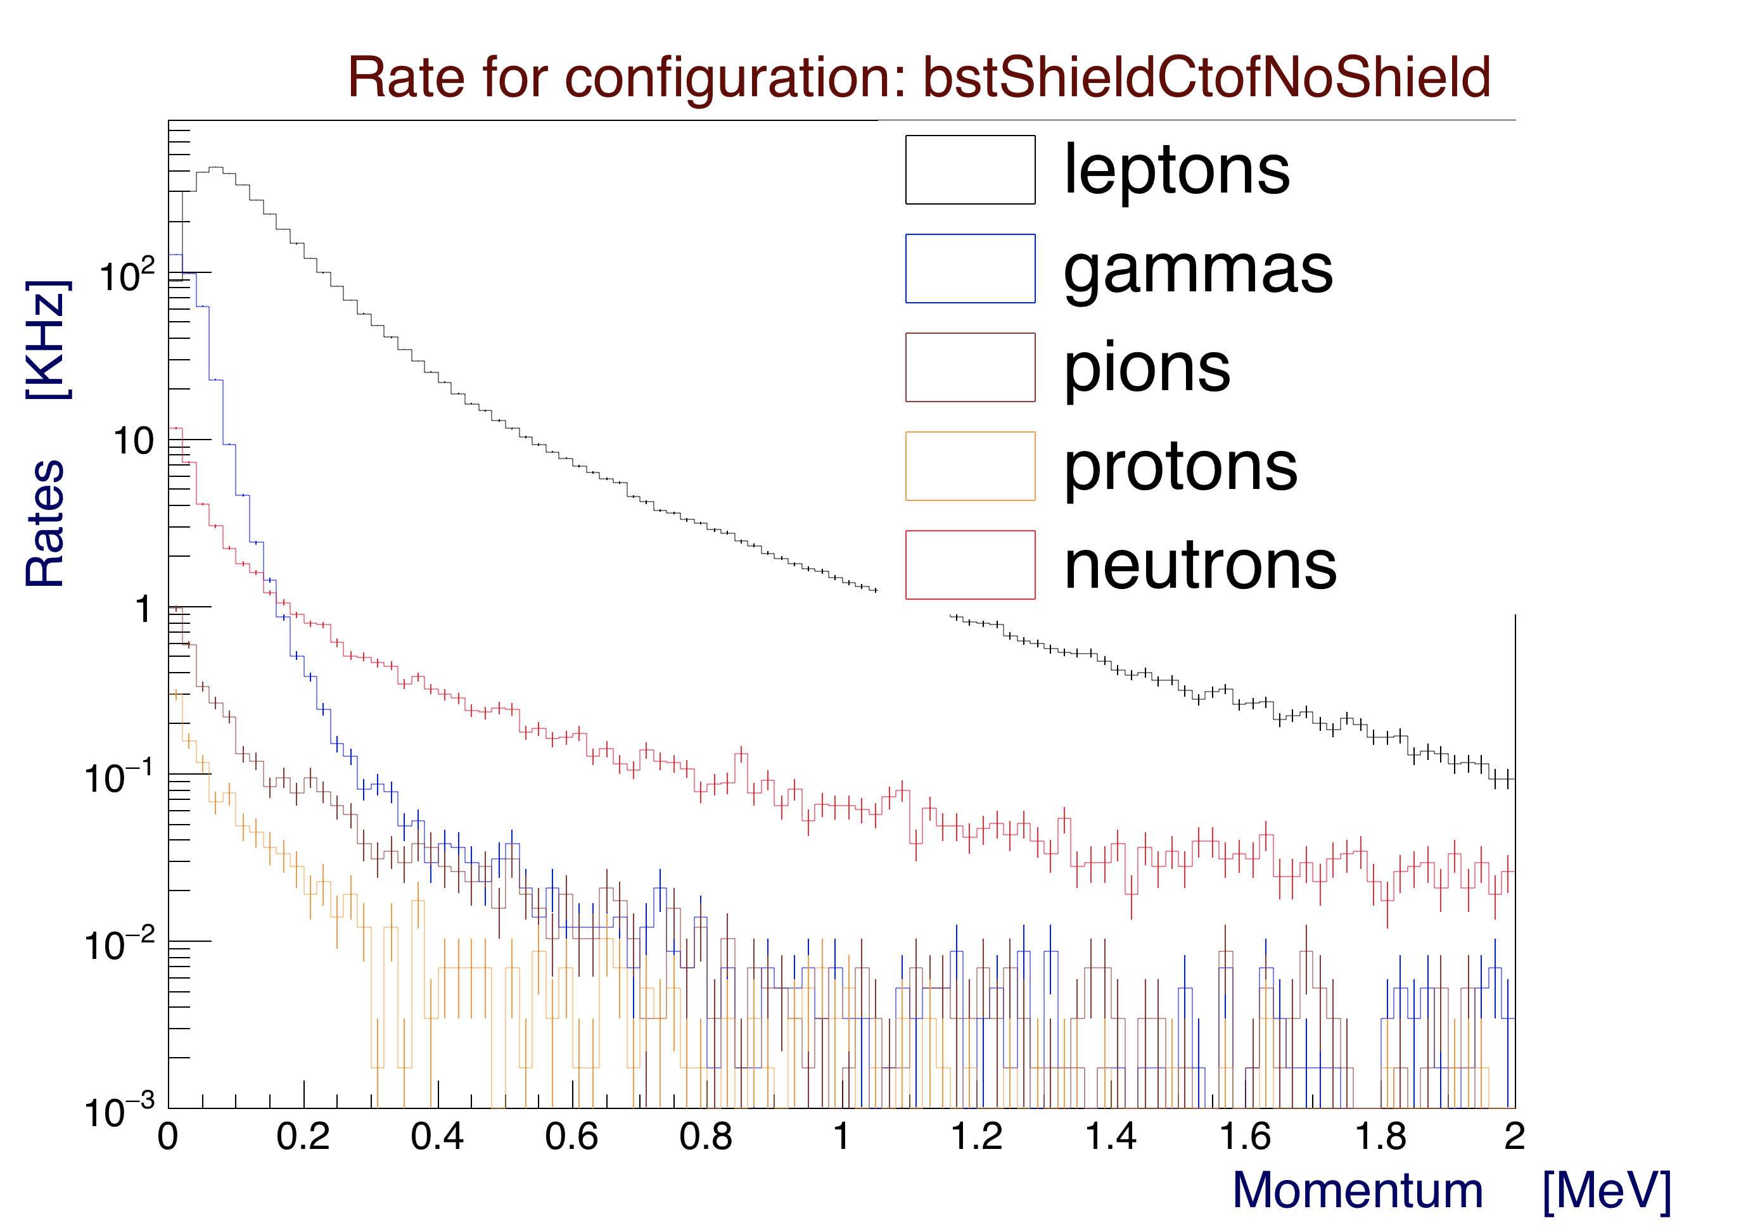

*Figure 13: Single counter rates as a function of momentum for particles hitting CTOF, zoomed in between 0 and 2 MeV. This is the configuration with the BST shielding only (51-m-thick tungsten). This plot is for the full nominal CLAS12 operating luminosity.*

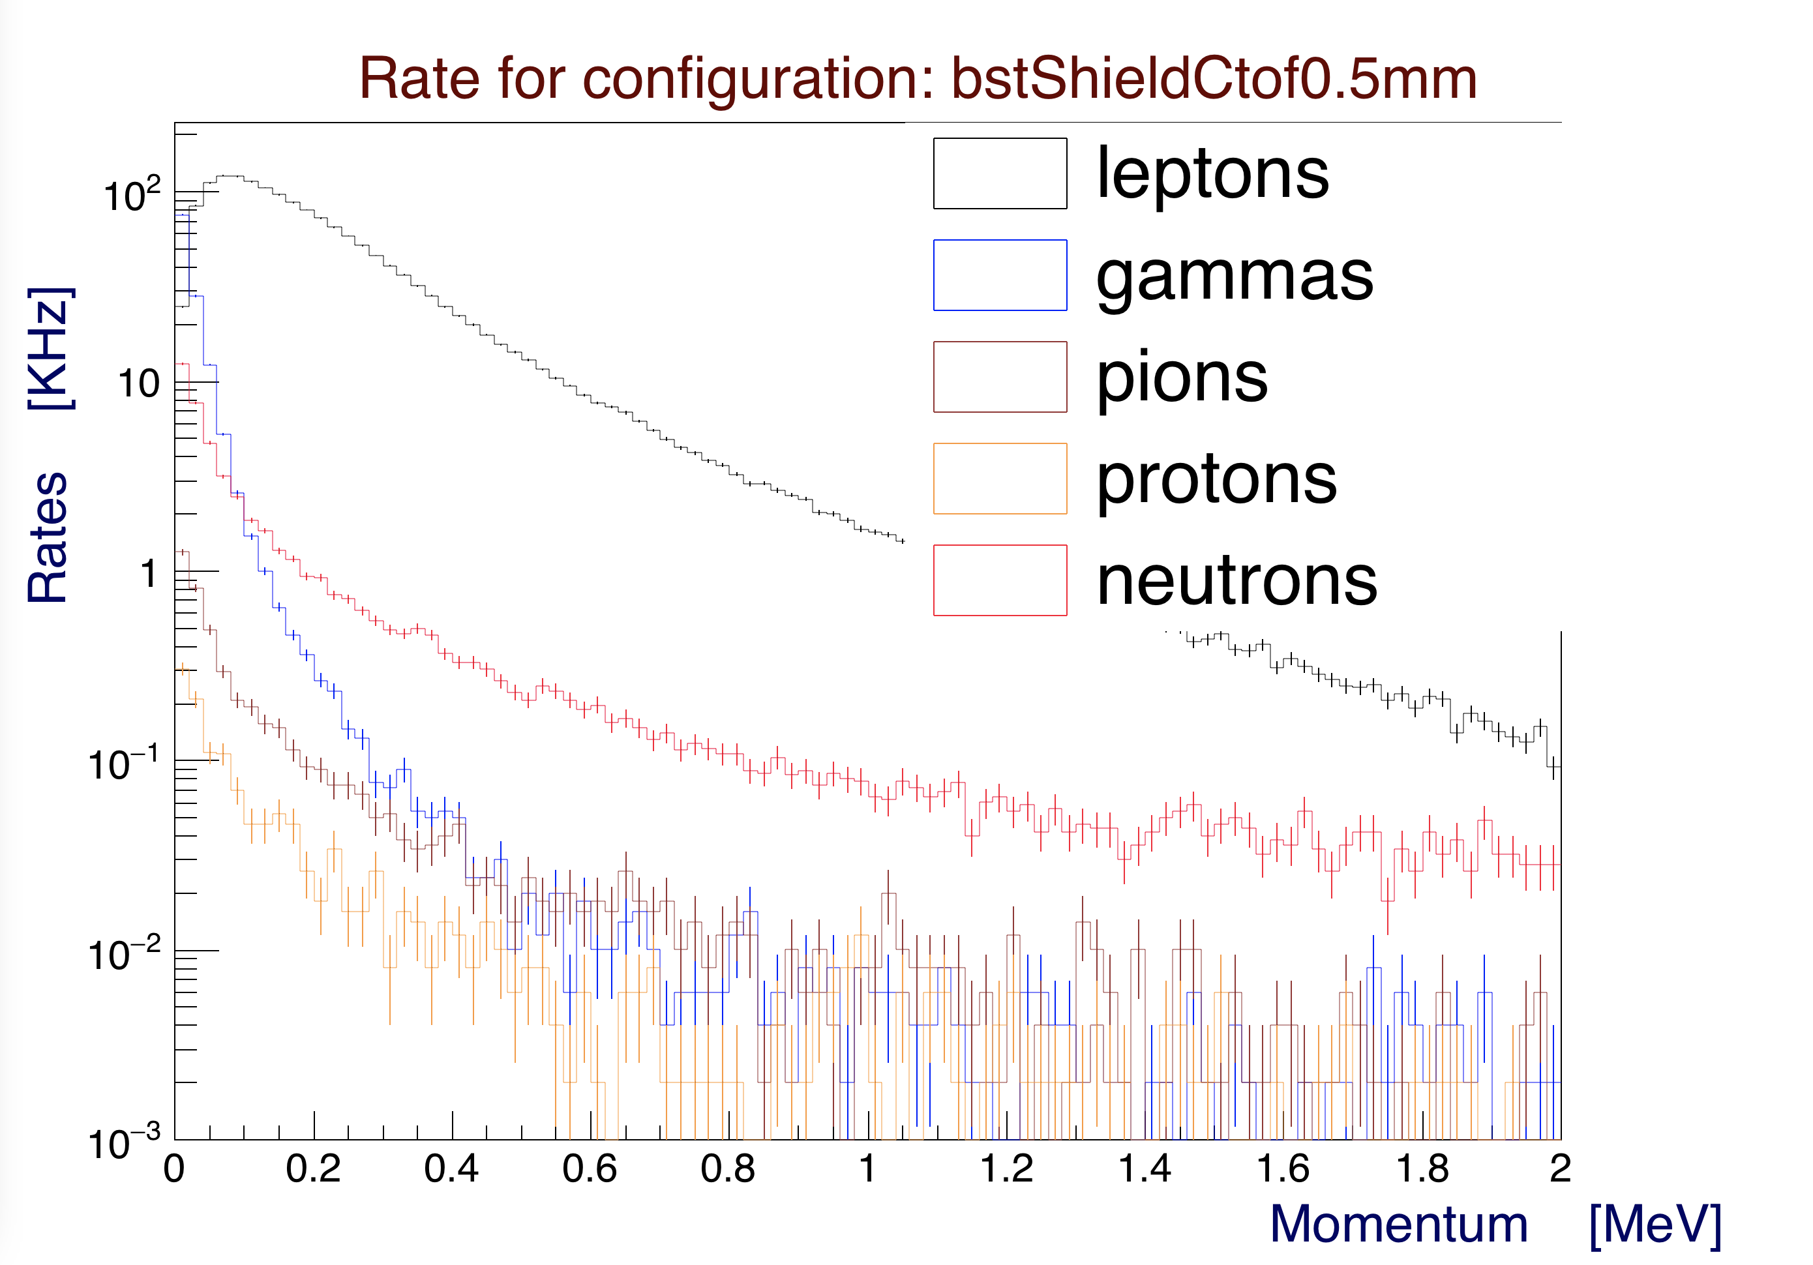

*Figure 14: Single counter rates as a function of momentum for particles hitting CTOF, zoomed in between 0 and 2 MeV. The additional 0.5 mm tungsten shield is added between the BMT and CTOF. It decreases background rates in this range of momenta. This plot is for the full nominal CLAS12 operating luminosity.*

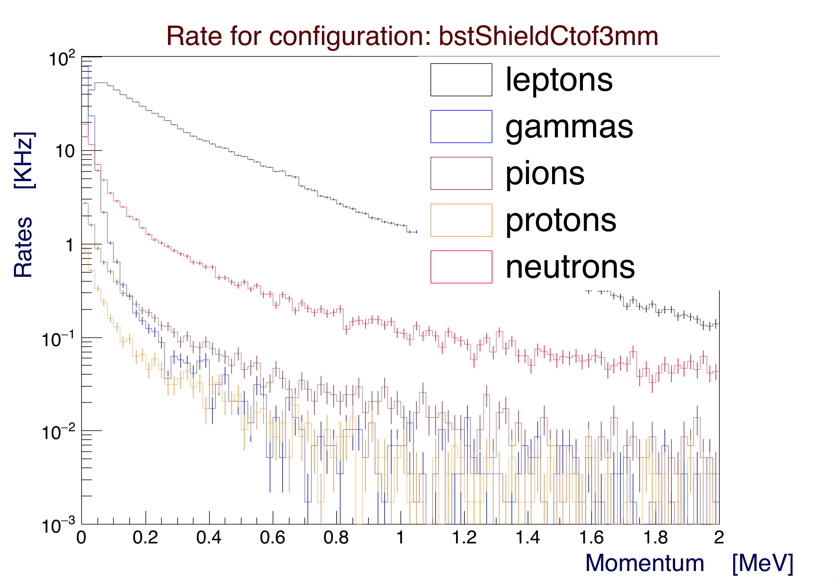

*Figure 15: Single counter rates as a function of momentum for particles hitting CTOF, zoomed in between 0 and 2 MeV. The additional 3 mm tungsten shield is added between the BMT and CTOF. It decreases background rates in this range of momenta. This plot is for the full nominal CLAS12 operating luminosity.*

**Simulated CTOF Upstream / Downstream Scaler Rates**

The rates above 1 MeV of energy at the face of the upstream and downstream PMTs were calculated by applying the attenuation length (140 cm) to the total energy deposited in the scintillators.

These rates are shown in Figures 16 and 17 for the upstream and downstream PMTs, respectively.

The upstream scaler rates show a 10% reduction in the simulation, in contrast with the experimental rates from FADC readout.

The simulation did not include Cherenkov light generated by secondaries in the light guides and reaching the PMTs. The total rates in the downstream part of the CTOF scintillators shown in the vertex distributions in Figures 7, 8, and 9 show a higher rate near the downstream light guides, which may explain the asymmetry seen in the data.

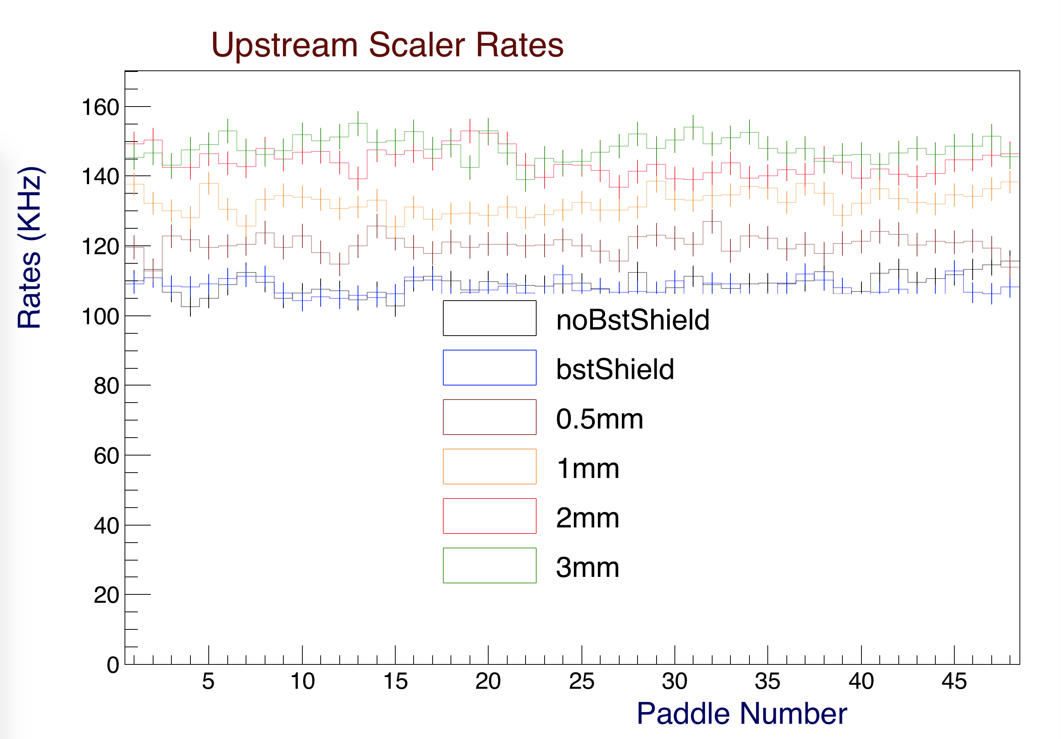

*Figure 16: Upstream scaler rates for the CTOF PMTs for different configurations with a 1 MeV energy threshold. The rates increase with the shielding thicknesses. This plot is for the full nominal CLAS12 operating luminosity.*

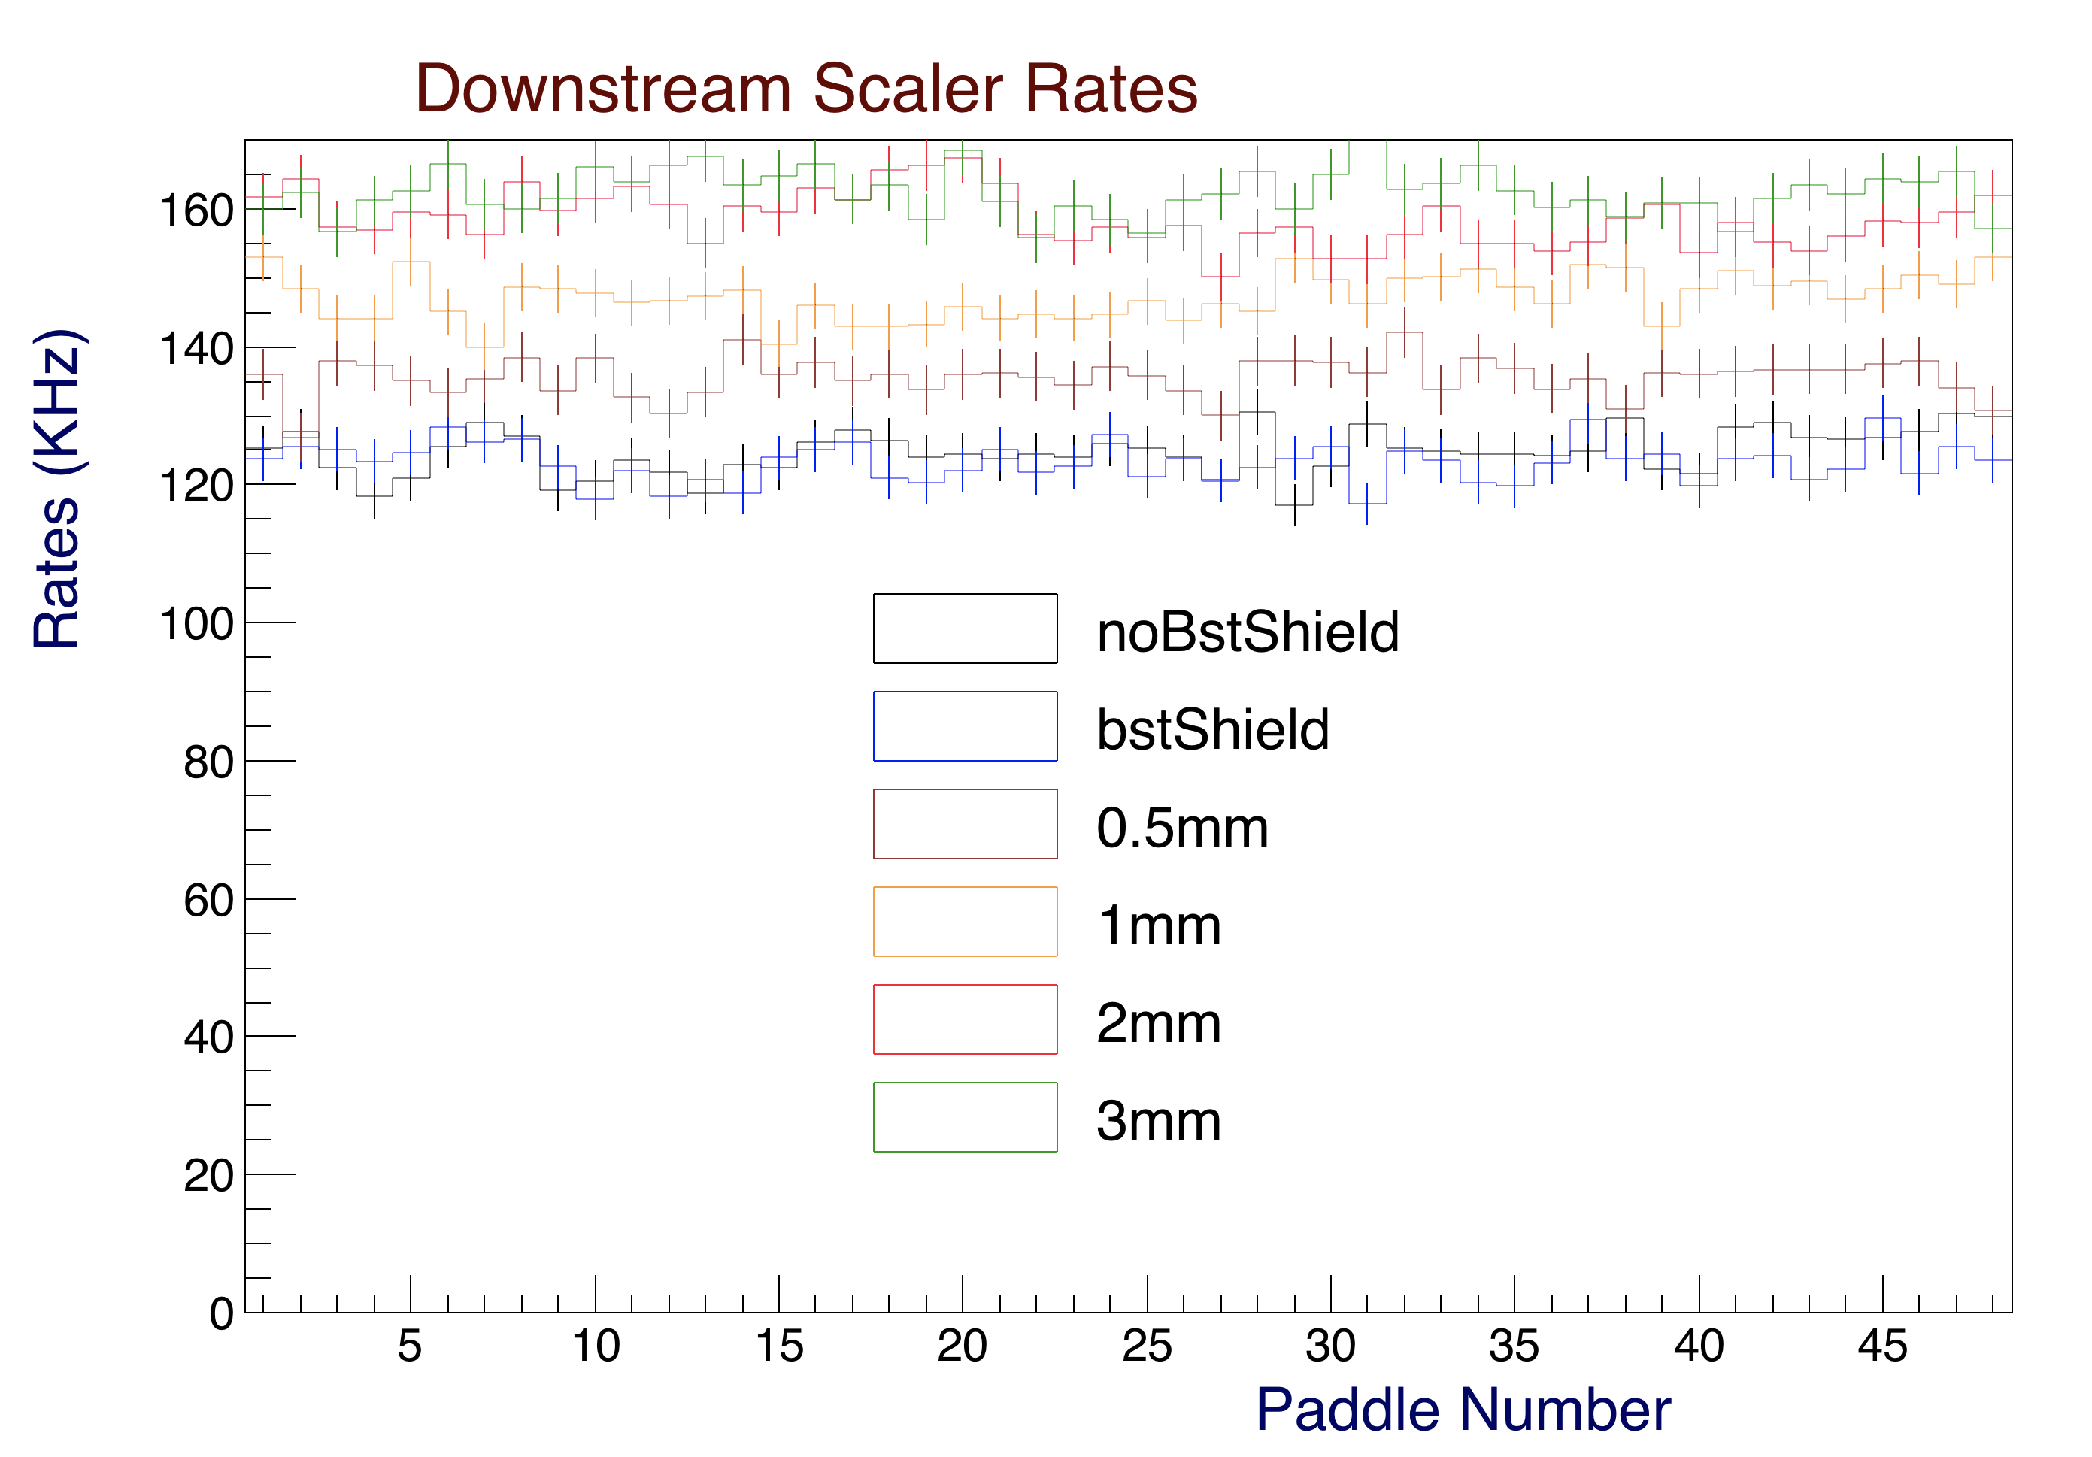

*Figure 17: Downstream scaler rates for the CTOF PMTs for different configurations with a 1 MeV energy threshold. The rates increase with the shielding thicknesses and are about 10% higher than the upstream rates. This plot is for the full nominal CLAS12 operating luminosity.*

**Simulated CTOF Upstream / Downstream PMT Anode Currents**

The CTOF PMT anode currents were calculated based on the attenuated energy at the location of the upstream/downstream PMTs using a flat conversion factor of 0.03 nC/MeV, corresponding to 200 p.e./MeV of deposited energy and a PMT gain of 1x106.

The computed upstream and downstream PMT anode currents are shown in Figures 18 and 19, respectively.

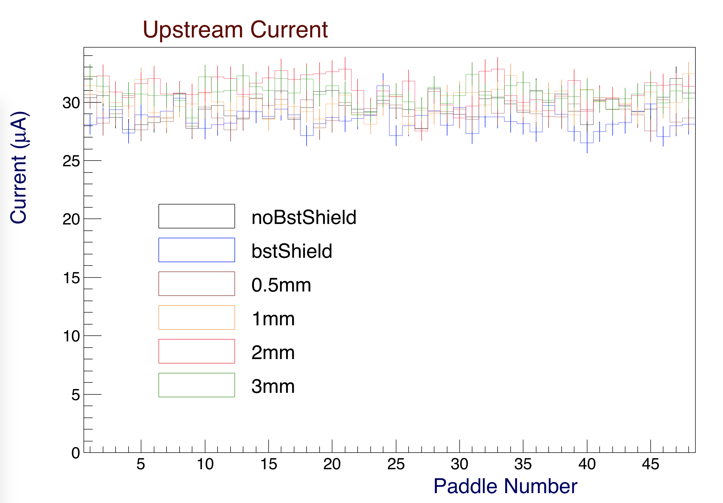

*Figure 18: Upstream currents (A) in the CTOF PMTs for the different shielding configurations. The current slightly increases with the shielding thickness. This plot is for the full nominal CLAS12 operating luminosity.*

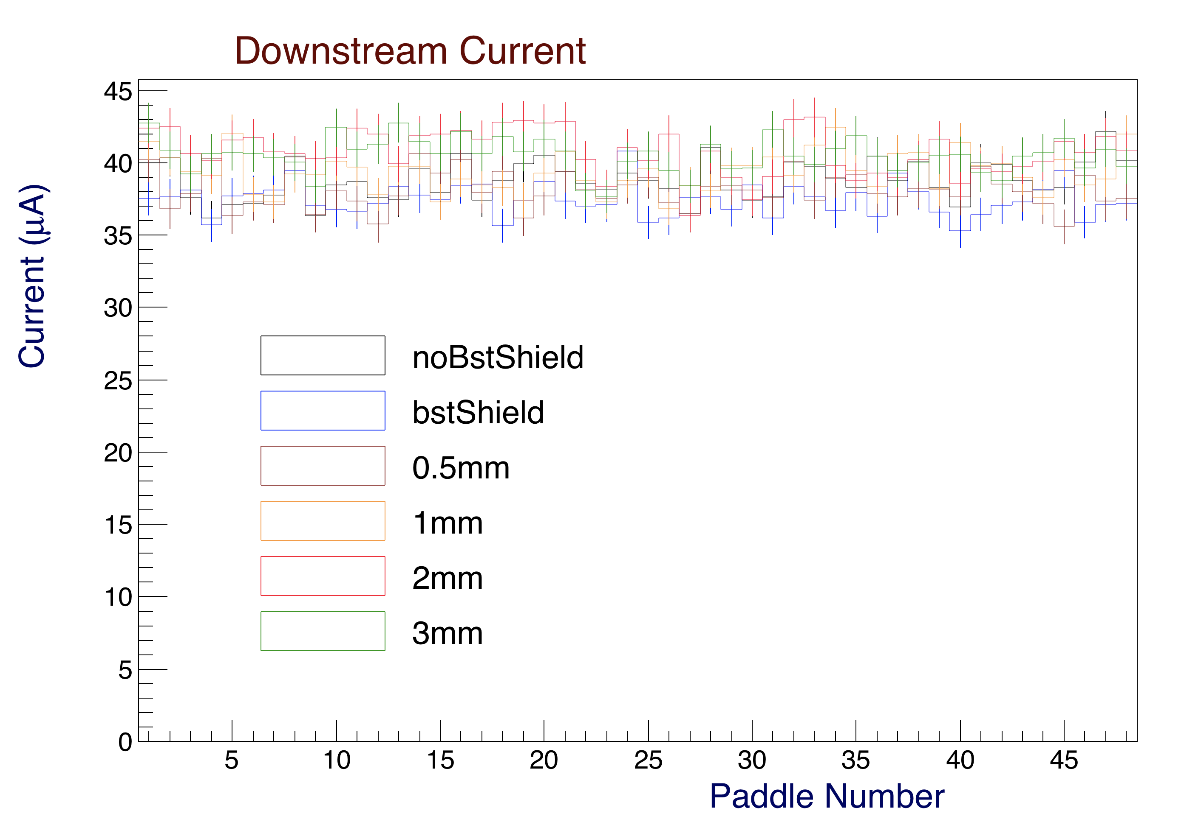

*Figure 19: Downstream currents (A) in the CTOF PMTs for the different shielding configurations. The current slightly increases with the shielding thickness and it is about 10% higher than the upstream current. This plot is for the full nominal CLAS12 operating luminosity.*

**Effect of Tungsten Shield on CTOF Scaler Rates**

On Feb. 5, 2018 a 51-m-thick tungsten shielding layer was included about the foam scattering chamber. The CTOF PMT scaler rates from the FADC readout were found to decrease by about 16% on average. Fig. 20 shows EPICS read back of one CTOF FADC channel before and after the shielding layer was included using the same FADC TET threshold. The 16% reduction is based on a comparison of before rates (40000 Hz/35.2 nA) and after rates (14800 Hz/15.5 nA).

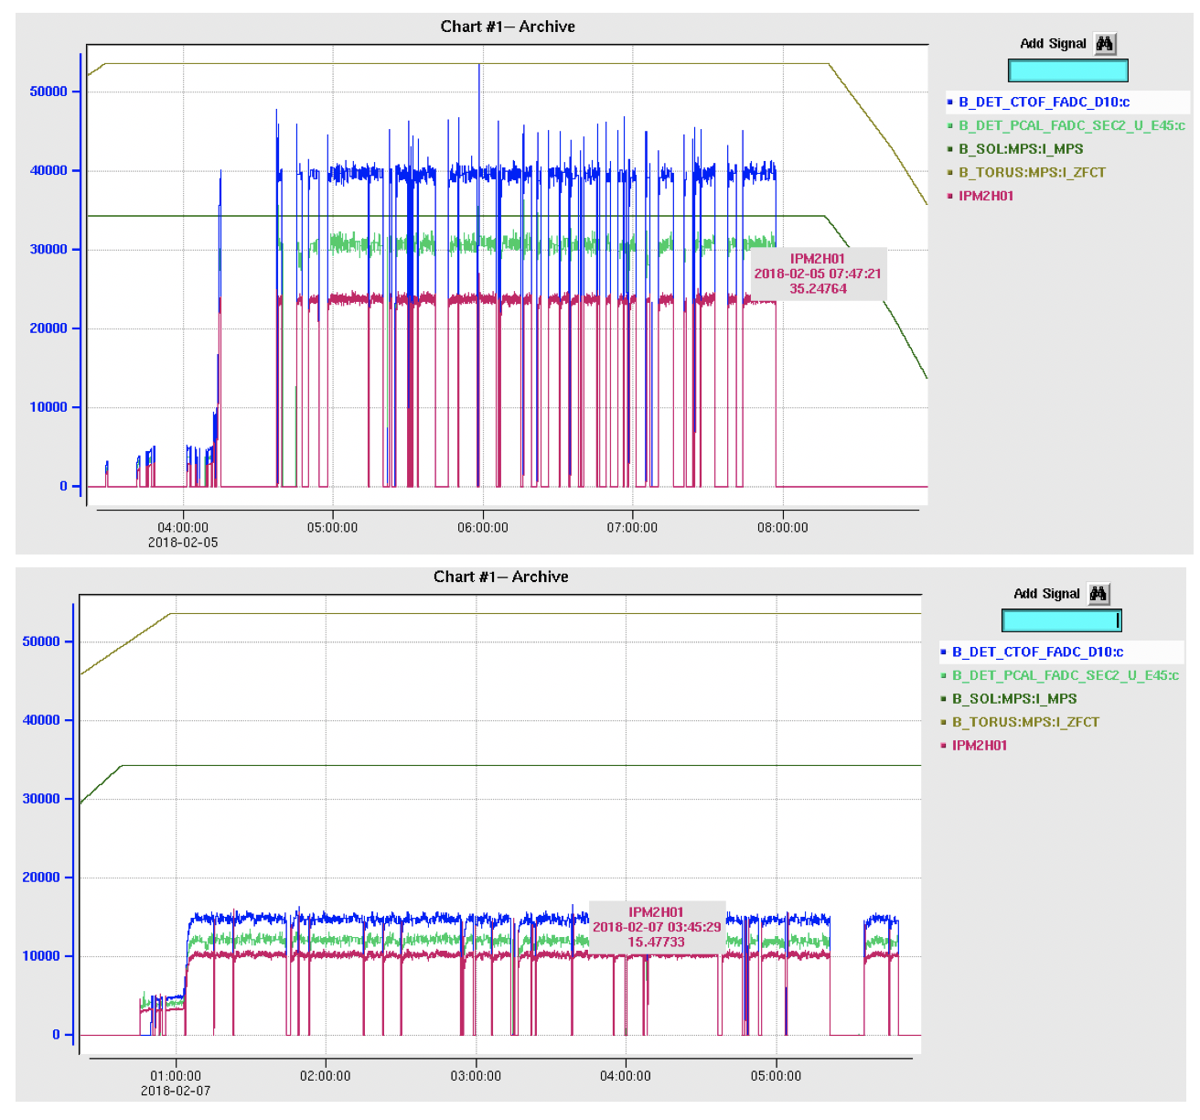

Figure 20: FADC scaler for the CTOF D10 PMT. (Top) Before W shield with a 35.2 nA beam on target. (Bottom) After the W shield was included with a 15.5 nA beam on target.

Using an absorption length of 0.3 g/cm2, the effective shield thickness is 0.0051 cm * 11.45 g/cm3 = 0.057 g/cm2. The intensity reduction is then given by: 1-exp(-0.057 g/cm2/0.3 g/cm2) = 17%.

**CTOF Rates and PMT Currents from Direct Measurements**

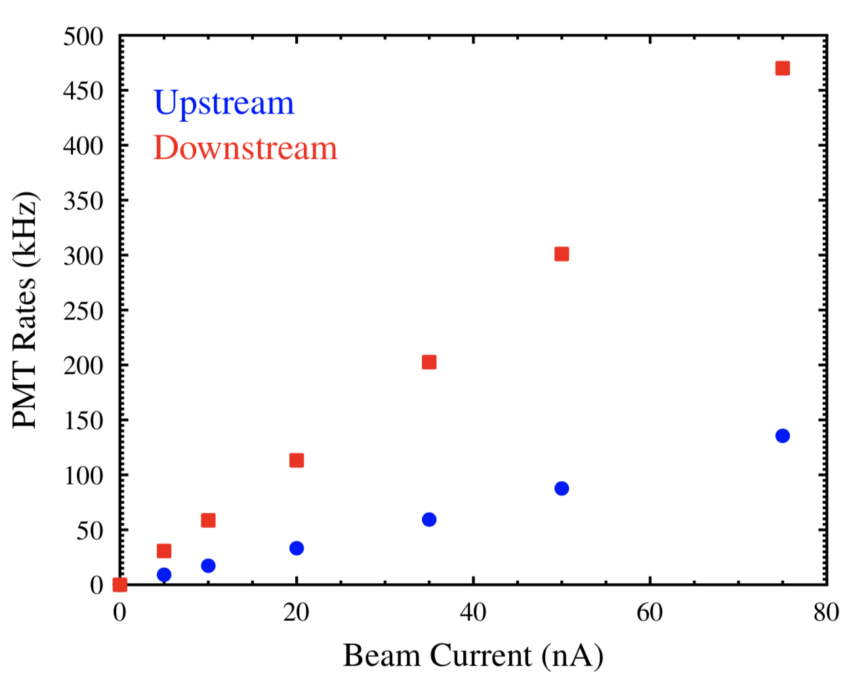During beam operations the average upstream and downstream PMT scaler rates based on the FADC readout with a 1 MeV energy threshold applied were recorded as a function of beam current. These data are shown in Figure 21. A direct comparison to the Monte Carlo results shown in Figures 16 and 17 show that the actual measured rates at the full operating luminosity of CLAS12 (75 nA) are in fair agreement for the upstream CTOF PMTs (100 kHz data, 140 kHz simulation), but are significantly different for the downstream CTOF PMTs (475 kHz data, 150 kHz simulation).

Figure 21: Measured average CTOF counter rates in the upstream and downstream PMTs (kHz) vs. beam current (nA).

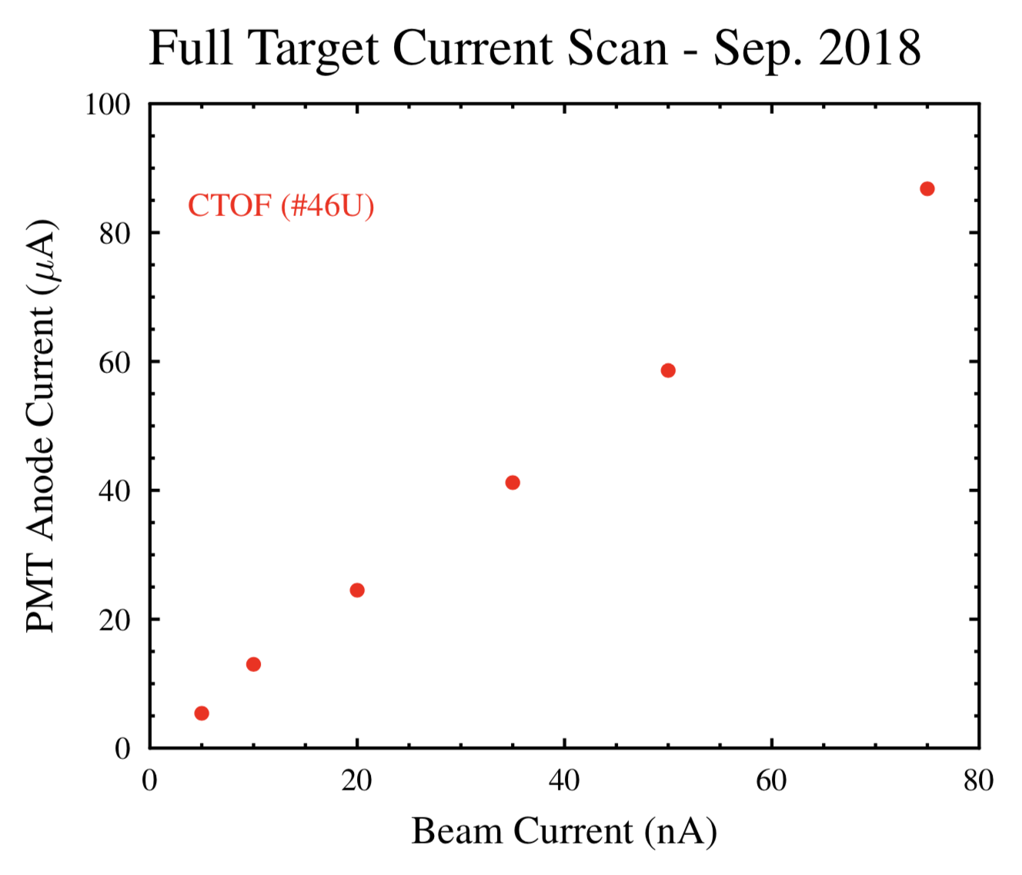Direct measurements of the CTOF PMT anode currents were made of one upstream PMT vs. beam current as shown in Figure 22. At the full nominal operating luminosity of CLAS12 the measured PMT anode current (90 A) is about a factor of three larger than that computed from simulations.

Figure 22: Measured PMT anode current (mA) vs. beam current (nA) for one upstream CTOF PMT.

**Physics Processes**

The GEMC simulation catalogues the process ID that generated a particle. In Figure 23 the transverse vertex coordinate (RV) vs. process ID is displayed without threshold for the 1 mm shield. At the bottom of the picture the process ID catalogues (below 41, the most relevant for this study) are referenced.

Compton scattering is the main process happening inside the CTOF paddles (ID = 2). One can see that there are a lot of gamma conversions (ID = 5) in the shield at RV ~ 24 cm. The hadronic processes have ID > 7. One can see contributions from the target (photo- and electron-nuclear), then hadronic elastic within the CTOF paddles. The shield is the source of inelastic scattering (proton and neutron, ID = 30, 31) and pion production, (ID=40, 41).

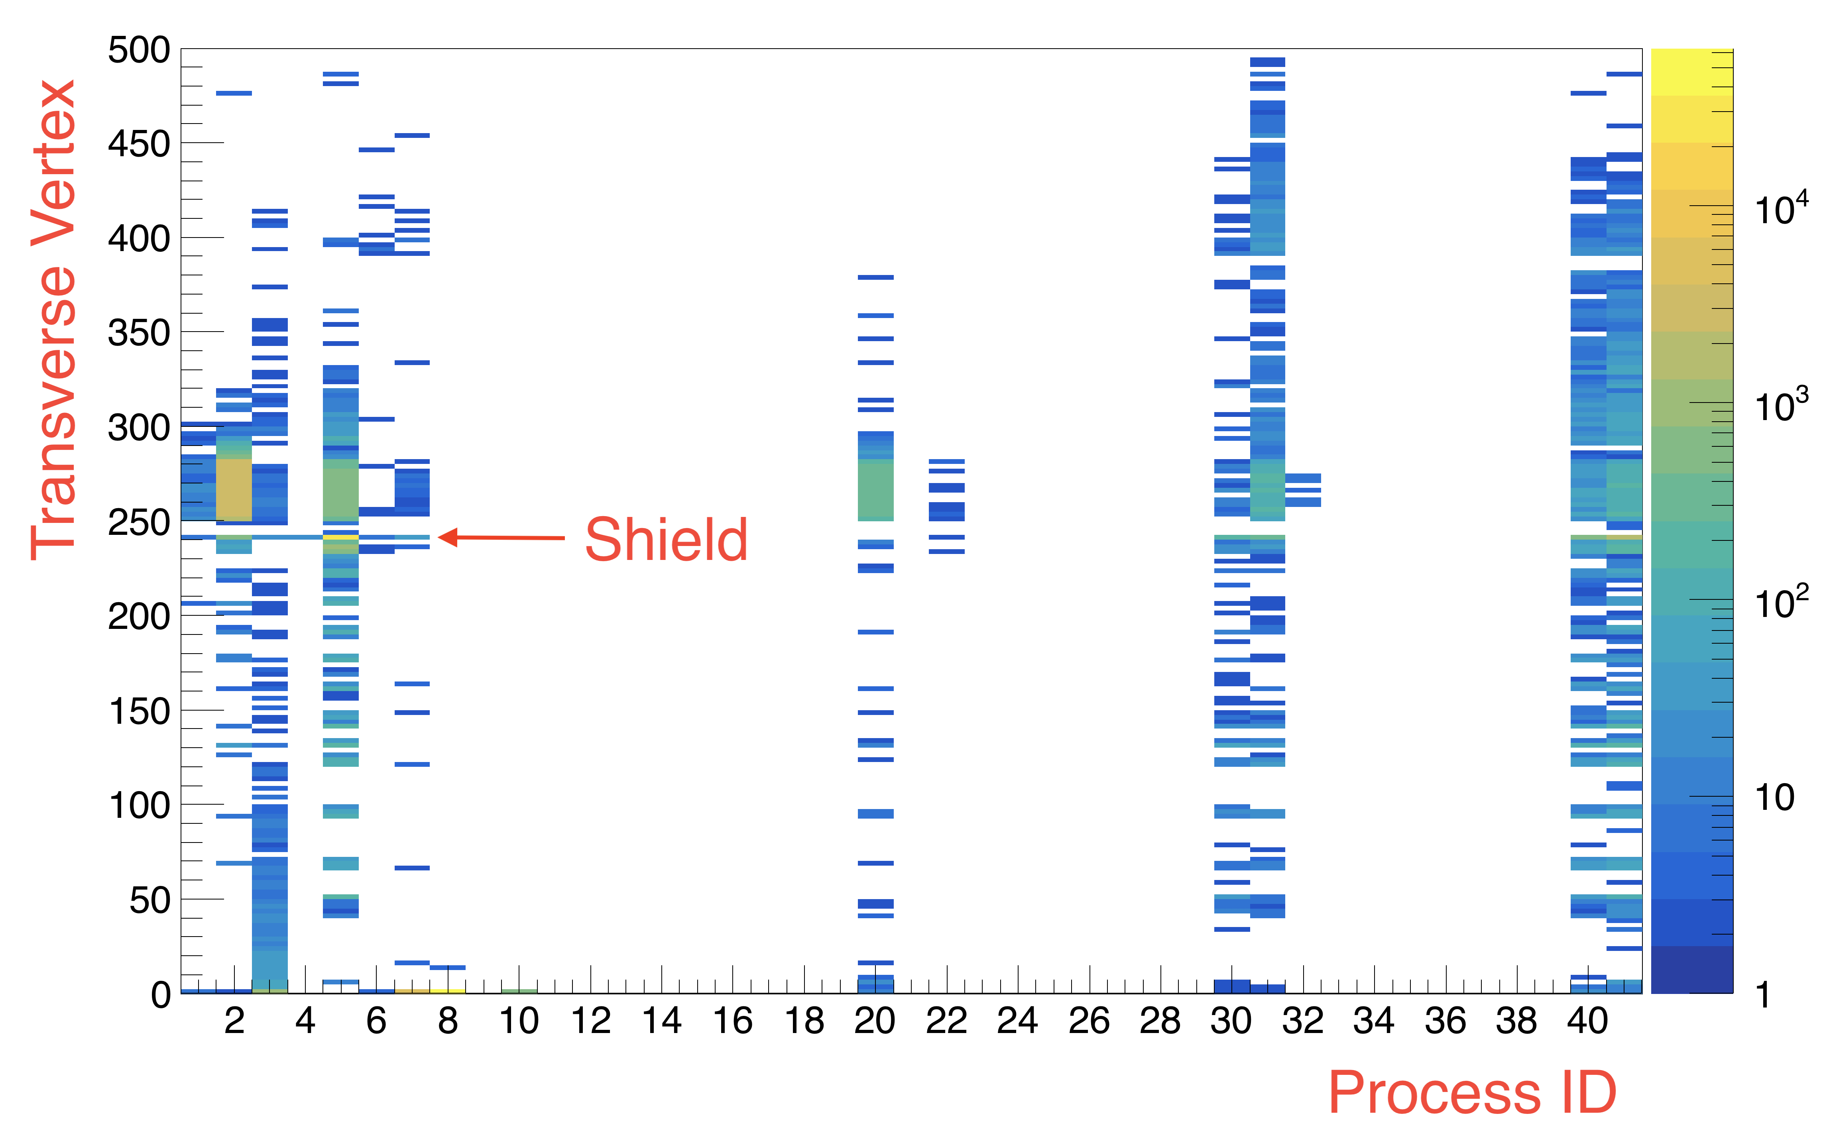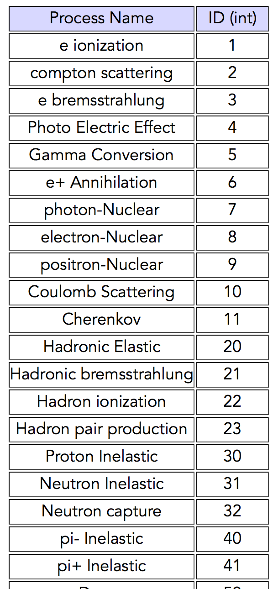

*Figure 23: Left: Transverse vertex of particles depositing at least 1 MeV in CTOF is shown versus the process ID. Right: process ID catalogue. The shield is causing a lot of gamma conversions and hadronic processes, including producing pions.*

In Figure 24 the transverse vertex of particles depositing at least 1 MeV in CTOF is plotted versus the particle ID. One can see the shield is responsible for many electrons and pions.

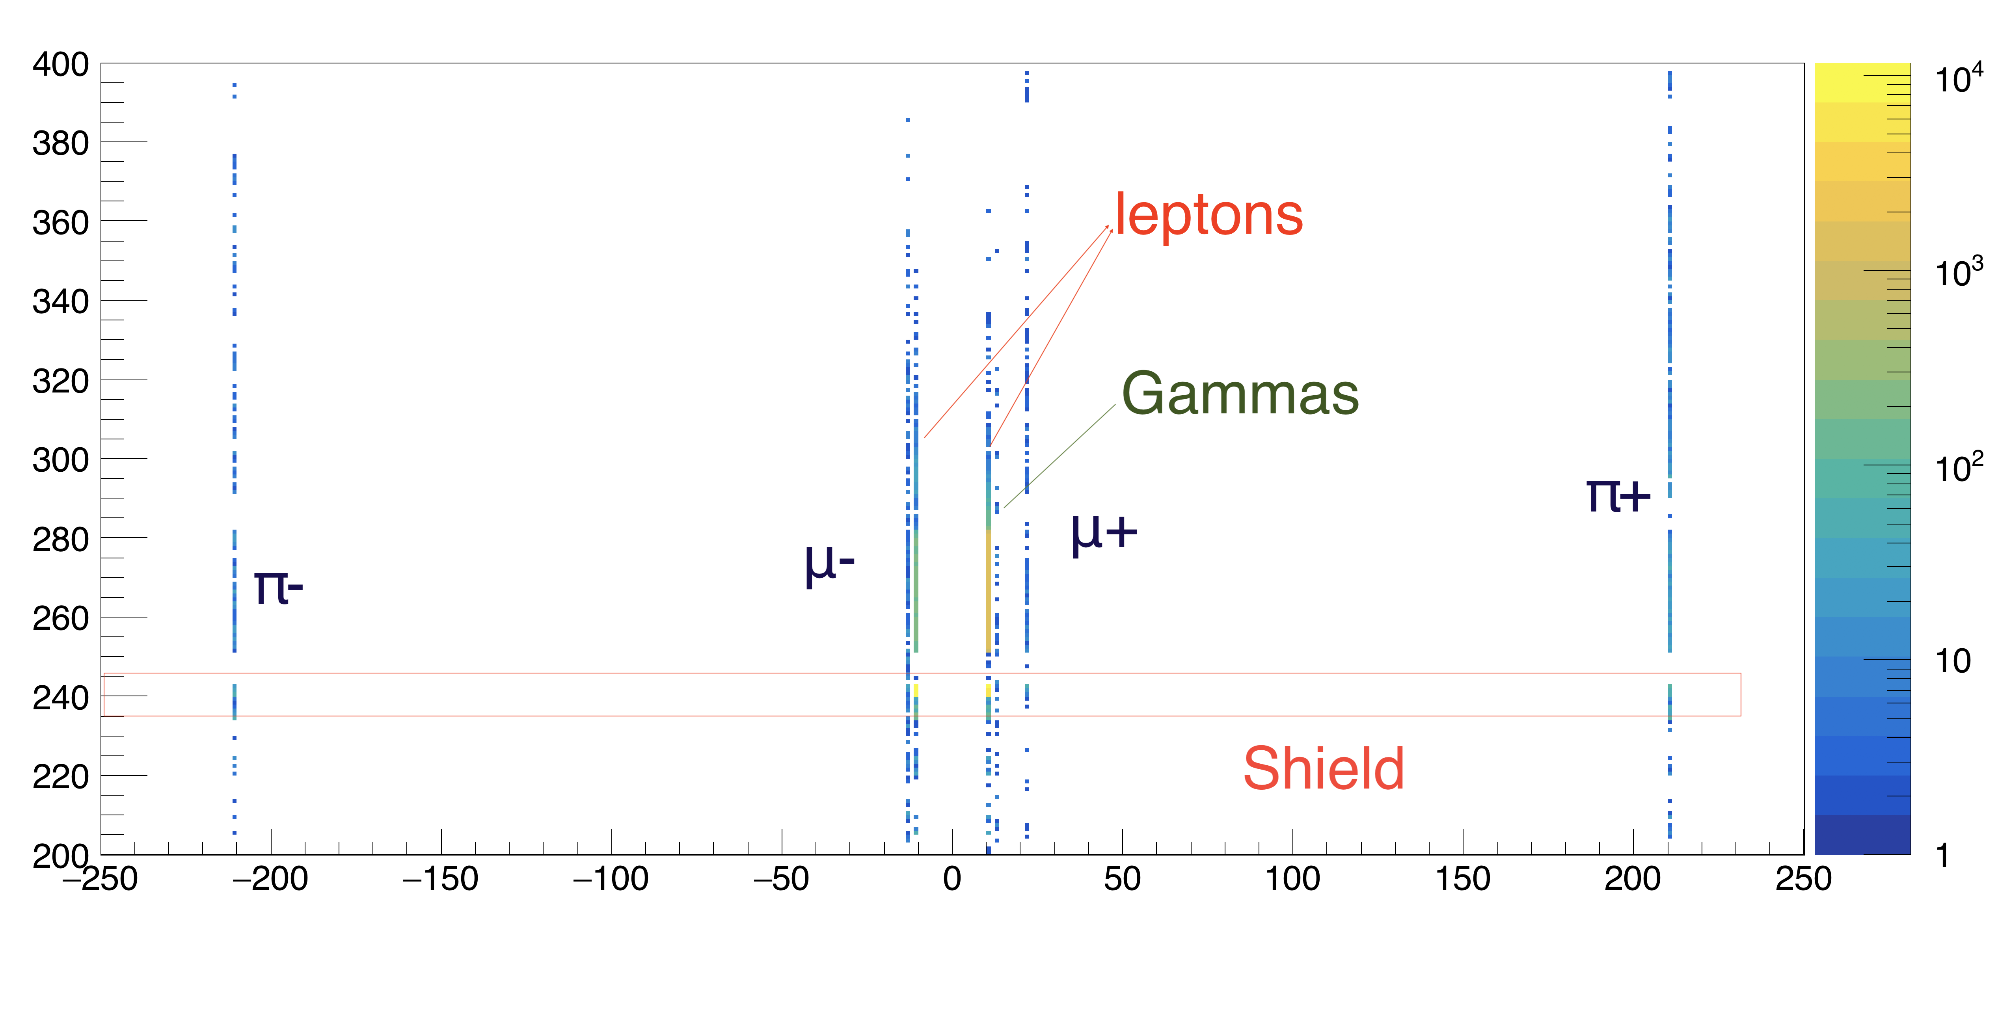

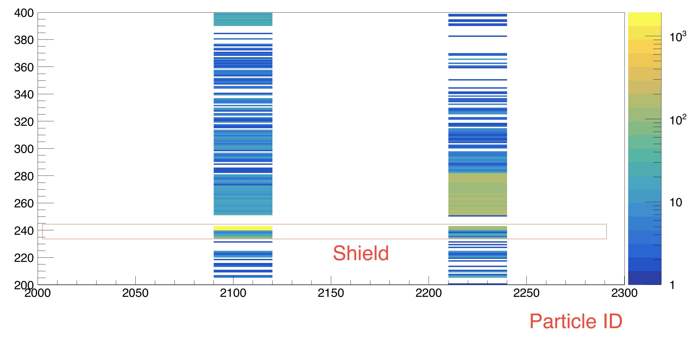

*Figure 24: Transverse vertex of particles depositing at least 1 MeV in CTOF is shown versus the particle ID. Top: gammas (22), electron positron pairs (11 and -11), muons (13 and -13) and pions (211 and -211). Bottom: protons (2212) and neutrons (2112). The shield is seen producing e+e- pairs, pions, and protons and neutrons.*

**Addendum: 100 microns shield**

In an effort to stop the very low energetic gammas but not photo-produce secondaries in the shield, a thin 100 microns configuration was added to the configurations simulated. While it did filter low energetic gammas, it was not enough to compensate the secondaries created in the MeV range, and the PMTs calculated current did not improve, see figures 25 and 26.

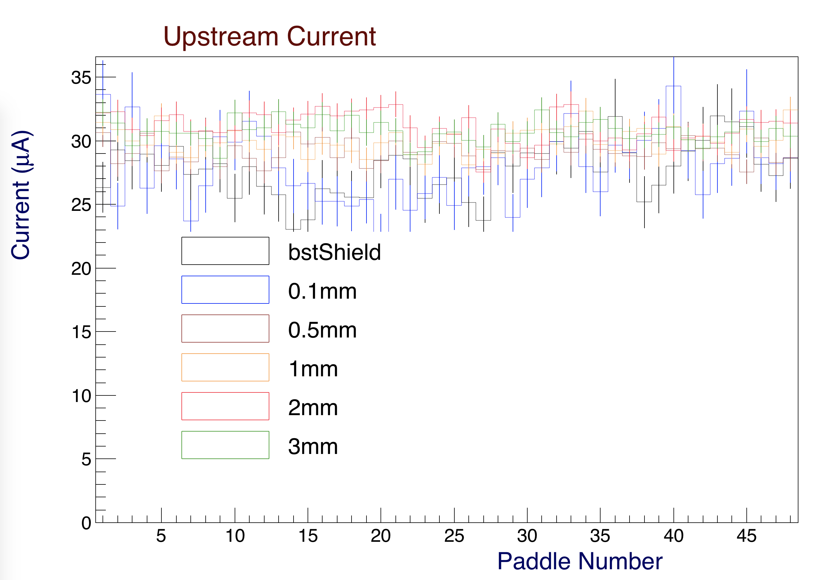

*Figure 25: Upstream currents (A) in the CTOF PMTs for the different shielding configurations. The current slightly increases with the shielding thickness. This plot is for the full nominal CLAS12 operating luminosity.*



*Figure 26: Single counter deposited energy spectra for the different shielding configurations. This plot is for the full nominal CLAS12 operating luminosity*

**Summary and Conclusions**

This note shows predictions from the CLAS12 simulation for the CTOF counter rates with different shield configurations. These include a 51 m tungsten shield surrounding the foam scattering chamber inside of the BST and 4 different tungsten shields outside of the BMT inside of the CTOF counters of thicknesses 0.5, 1, 2, and 3 mm. The simulation also provides predicted counting rates and PMT anode currents that can be compared directly against beam measurements with the CTOF.

From this study three conclusions can be drawn:

1. There is no shielding solution using tungsten in the space available between the BMT and the CTOF that results in reduced PMT anode currents given the current simulation. The simulation shows that the rates of low-energy background are significantly reduced, but that due to conversions in the added shielding material, the overall energy deposited in the CTOF actually increases.
2. The measured rates in the counters show a factor of 2 to 3 difference between the upstream PMTs and the downstream PMTs that is not reflected in the simulations. The simulations show only a ~10% difference.
3. The measured PMT anode currents for the upstream CTOF PMTs are found to be a factor of two higher than the computed currents. Note that no direct measurements of the downstream CTOF PMT currents have been made to date. It remains to be seen if the downstream PMT currents are a factor of 2-3 higher than the upstream PMT currents following the ratio seen in the measured scalers (that have a 1 MeV threshold for energy deposited).

The main difference between the actual detectors and what is included in the simulations is that Cherenkov light created in the light guides and transported to the PMTs is likely an important contribution to the overall rates and currents. This effect is not included in the simulations. It is interesting that the measured counter rates even without beam (where the counters only see cosmic ray muons) show a 50% larger downstream PMT rate than upstream PMT rate that is not reflected in the simulations.

**References**

*[1] M. Ungaro,* ***CLAS12-Note 2017-013****:* Corrections to CLAS12 target design.